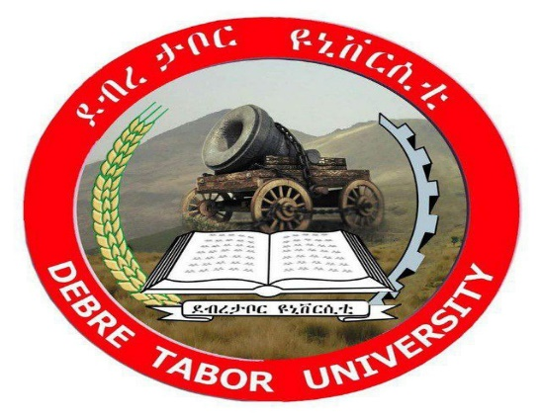
DEBRE TABOR UNIVERSITY
GAFAT INSTITUTE OF TECHNOLOGY
DEPARTMENT OF COMPUTER SCIENCE
PROJECT DOCUMENTATION
TITLE: WEB BASED HUMAN RESOURCE MANAGEMENT SYSTEM FOR DTU
Prepared By: Group 4
Group members ID
1. Birhanu Mulugeta -------------------------------------------------------DTU14R0704
2. Chernet Fikadu --------------------------------------------------------- DTU14R0480
3. Eyobel Mulatie ---------------------------------------------------------- DTU14R6014
4. Eyuel Adugna-------------------------------------------------------------DTU14R0247
5. Mulugeta Alemu -------------------------------------------------------- DTU14R0778
6. Zikra Burhan ------------------------------------------------------------- DTU14R1895

In Partial Fulfillment of the Requirements for the Degree of Bachelor of Science in Computer Science
Advisor: Mr. Habtamu A.
Debretabor, Ethiopia 2025 G.c

DECLARATION

We declare that the project document is our original work and has not been presented for a degree in any other university and all the sources of material used for the project have been duly acknowledged.

Name and signature of project group members.

Name signature
- Birhanu mulugeta …………………………….
- Cherenet fikadu …………………………….
- Eyobel mulatie ……………………………..
- Eyuel adugna ……………………………...
- Mulugeta alemu ……………………………..
- Zikra Burhan ………………………………

This is to declare that this project is done by forth year computer science students under the title of Human Resource Management System for DTU.

This project has been submitted for examination with my approval as University advisor.

------------------------------------------ -----------------------------

Name of the advisor signature

Examining committee members Signature Date
- Examiner 1-------------------- ----------------- ---------------
- Examiner 2-------------------- ----------------- ---------------
- Examiner 3 -------------------- ----------------- ---------------

ACKNOWLEDGMENT

First and foremost, we would like to thank almighty God that permit us to do and enable us to be successful in our final year project and to be complete without any problem as his permission. We also pass our sincerest thanks to our advisor Mr. Habtamu A., who have given timely advice as well as encouragement to completion of our project and his continuous support in every phase of this project. Additionally, we would like to thanks to human resource office members especially for Ato Chale Semagne, HR manager of DTU. They helped us by giving information about the current system. We thanks all our instructors who thought us in last seven semesters. Finally, giving great thanks for all of those who participate and provide support directly or indirectly in this project.

ACRONYMS AND ABBREVIATIONS

DTU Debretabor University

HR Human Resource

HRMS Human Resource Management System

UML Unified Modeling Language

DB Database

MERN Mongo dB, Express, React and Node.js

GUI Graphical User Interface

ID Identification

BR Business Rule

RIO Return of Investment

CRS Class Responsibility Collaboration

OPERATIONAL DEFINITION
- Applicant is a person who want to search and apply in a particular job.
- Employer is a person who works in the organization.
- Job portal is an application allows jobseekers and recruiters to connect. The application provides the ability for job seekers to create their accounts, upload their profile and resume, search for jobs, view different job openings, apply for jobs.
- System administrator is the one which controls the overall activity of the system.
- Department head is the one who is the representative of each departments, representative of cafe, departments and library.
- Vacancy announcement is a channel through which the human resource office of DTU posts all its available vacancies
- MERN is a web development stack consisting of MongoDB, Express.js, React.js, and Node.js. It allows developers to build full-stack JavaScript applications with a single language across the frontend and backend.

Table of contents
DECLARATION i
INTRODUCTION 1
1.1. Background 2
1.1.1. Organization Overview 2
1.1.2. Project Overview 2
1.2. Motivation 3
1.3. Statement of the Problem 4
1.4. Objectives 5
1.4.1. General objective 5
1.4.2. Specific objectives 5
1.5. Scope of the project 6
1.6. Significance of the project 7
1.7. Feasibility study 8
1.7.1. Economic Feasibility 8
1.7.2. Technical Feasibility 9
1.7.3. Operational Feasibility 10
1.8. Methodology 11
1.8.1. Data collection methods 11
1.8.2. Software Development Model 11
1.8.3. Technology stack and modeling tools 12
1.9. Roles and Responsibilities 13
1.10. Work Breakdown Structure (WBS) 14
1.11. Project Schedule 15
STUDY OF EXISTING SYSTEM 16
2.1. Introduction 16
2.2 Existing System Description 16
2.2.1. Players of previous system 17
2.2.2. Explanation of the business rule of the organization 18
2.3. Proposed System Description 18
2.3.1. Purpose of the new system 20
SOFTWARE REQUIREMENT SPECIFICATION 20
3.1. Introduction 20
3.2. General Constraints 21
3.3 Specific Requirements 22
3.4. Functional Requirements 24
3.4.1. User Management 24
3.4.2. Employee Management 24
3.4.3. Recruitment and Onboarding 24
3.4.4. Leave Management 25
3.4.5. Work Experience Management 25
3.4.6. Reporting 25
3.4.7. Notification System 25
3.4.8. Data Security 25
3.5. Use Case Design 25
3.5.1. Actor identification 26
3.5.2. Use case identification 26
3.5.3. Use case description 28
3.6. Sequence diagram 38
3.7. Activity diagram 45
3.8. Class diagram 48
3.9 Data Structural Model 50
3.9.1. Entity relationship (ER) model 50
3.10 Non-Functional Requirements 53
3.10.1. Performance 53
3.10.2. Reliability 53
3.10.3. Availability 54
3.10.4. Security 54
3.10.5. Maintainability 54
3.10.6. Portability 55
SYSTEM DESIGN 56
4.1. Design overview 56
4.1.1. Objectives of the System Design 56
4.2. System architecture design 56
4.2.1 System Interface Description 57
4.2.2. Component Diagram 57
4.3. User Interface Design 59
4.3.1. Description of the User Interface 59
4.3.2 Screenshot Images 60
4.4 Database Design 62
4.4.1 Persistent Database Design 62
CHAPTER FIVE 64
SYSTEM TESTING 64
5.1. System overview 64
5.2. Test approach 64
5.3. Test Plan 65
5.3.1. Features to be tested 65
5.3.2. Features Not to be Tested 66
5.3.3. Testing Tools and Environments 66
5.4. Test Cases 66
✓ Test Case 1: User Login 66
✓ Test Case 2: Employee Registration 67
✓ Test Case 3: Leave Application 67
✓ Test Case 4: Vacancy Application 68
5.5. Summary of Test Results 68
CHAPTER SIX 69
CONCLUSION AND RECOMMENDATION 69
6.1. Conclusion 69
6.2. Recommendation 70
6.3. Future Works 70
REFERENCES 72
APPENDIX 73

List of figures
Figure 1: Gantt chart 15
Figure 2: Use Case Diagram 27
Figure 3: Sequence Diagram for Login 38
Figure 4: sequence diagram for employee requisition 39
Figure 5: sequence diagram for post announcement 40
Figure 6: sequence diagram for view and register 41
Figure 7: sequence diagram for placement 42
Figure 8: sequence diagram for apply leave 43
Figure 9: activity diagrams for login 44
Figure 10: activity diagrams for employee requisition 44
Figure 11: activity diagram for post announcement 45
Figure 12: activity diagram for view and apply 45
Figure 13: activity diagram for apply leave 46
Figure 14: activity diagrams for placement 46
Figure 15: class diagram 48
Figure 16: Entity relationship (ER) diagram 51
Figure 18: component diagram 57
Figure 20: user interface for login 59
Figure 21: user interface for employee requisition 59
Figure 22: user interface for apply 60
Figure 23: user interface for employee placement 60
Figure 24: user interface design for leave application 61
Figure 25: Data base design diagram 62

List of table
Table 1: Roles and Responsibilities 13
Table 2: project schedule 15
Table 9: Main Course of Action about Login 28
Table 10: Main Course of Action about employee requisition 29
Table 11: Main Course of Action about post announcement 30
Table 12: Main Course of Action about registering applicant online 31
Table 13: Main Course of Action about placement 31
Table 14: Main Course of Action about Update employee 32
Table 15: Main Course of Action about searching 33
Table 16: Main Course of Action about deleting employee 33
Table 17: Main Course of Action about apply leave 34
Table 18: Main Course of Action about send employee leave application 34
Table 19: Main Course of Action about approve leave application 35
Table 20: Main Course of Action about notification 36
Table 21: Main Course of Action about report 36
Table 22: main course of action about attendance tracking 37

ABSTRACT
The Human Resource Management System (HRMS) of Debre Tabor University is designed to provide a streamlined way to manage and increase efficiencies for all human resources at the University. With the implementation of the HRMS, the need for a systematic way to track, manage, and report on all employee records and leave requests, as well as the ability to generate reports, has been met through the use of one single, user-friendly, and comprehensive online application.
The three-layer architecture of the HRMS consists of a presentation layer, a business logic layer, and a data storage layer. The presentation layer consists of responsive design, ensuring that the HRMS provides optimal user experience across a variety of devices and screen sizes. The business logic layer provides a robust level of programming which enables the HRMS to manage employee records and leave requests in real-time. The back-end data storage layer stores all employee data securely, providing users with easy access to the HRMS data they need to support their operational functions.
The HRMS user interface (UI) is built using the latest web technologies, following recommended practices in UI design and development of databases, resulting in a greater level of operational efficiency and overall user satisfaction for all HRMS users.
In addition to providing an efficient way to manage employee records, protect sensitive employee information from unauthorized users, and comply with applicable privacy laws, the HRMS project provided a solid foundation for a more effective means of managing human resources, improved operational efficiencies for the University, and serves as a template for continued growth and development.

CHAPTER ONE

INTRODUCTION
With the increasing growth of technologies, Computerization of most of the organizational activity has occurred. As the number of work opportunities increase, the need for systems that can manage a high volume of employee information has also increased due to the increase in available human resources. This project focuses on developing a web-based Human Resource Management System for Debre Tabor University (DTU).
After the establishment of Debre Tabor University. A Human Resource Management Administration Office was established to manage all employee related functions. Prior to the use of this system, the DTU Human Resource Management Administration Office processed almost all data manually. This manual process had many limitations, including inconsistencies with data, delayed processing times, increased workloads, and inefficiencies with data storage.
The development of a web-based Human Resource Management System, using the built web application, solved many of the operational issues that affected the DTU Human Resource Management Administration Office. The online nature of the Human Resource Management System reduced operational costs, reduced travel times to the office, decreased the workload of administration, and reduced the amount of physical office space required for storing employee information.
The online Human Resource Management System provides an applicant registration process, employee information retrieval and modification capabilities, online registrations and placements for employees, and an online process for completing leave requests.

Background

Organization Overview
Debretabor University, established in 2008G.c, is one of the institution of higher education in Ethiopia, renowned for its commitment to academic excellence and community engagement. The university offers a diverse range of undergraduate and postgraduate programs across various disciplines, including health science, technology, humanities, and social sciences. With a mission to equip students with the necessary skills and knowledge for professional success, Debretabor University emphasizes research, innovation, and practical experience.
The institution is home to a vibrant community of students and faculty, fostering an environment that encourages collaboration and intellectual growth. Debretabor University actively engages with local and international partners to enhance its educational offerings and contribute to regional development.


Project Overview
The Web-Based Human Resource Management System (HRMS) was designed to streamline and enhance human resource functions at Debre Tabor University. Prior to the implementation of the system, HR processes were largely manual and fragmented, which led to inefficiencies in managing employee data, recruitment, attendance, leave requests and approvals, and report generation. These challenges resulted in delays, errors, and difficulties in effective decision-making. To address these challenges, the HRMS was developed using the MERN stack (MongoDB, Express.js, React.js, and Node.js) to create a robust and user-friendly web application. The system automated various human resource tasks, including employee management, recruitment, attendance tracking, leave management, and reporting.
Through the implementation of this solution, Debre Tabor University optimized its human resource operations, enhanced employee satisfaction, and supported informed and strategic decision-making processes.

Motivation
The motivation for implementing an automated Human Resource Management System (HRMS) at Debretabor University (DTU) stems from several critical factors that highlight the need for modernization in HR practices:
- Inefficiency in Manual Processes: The current system reliance on paper-based HR operations leads to significant inefficiencies. Manual processes are often slow, prone to errors, and difficult to scale as the university grows.
- Increasing Workforce Demands: As DTU continues to expand, the complexity of managing employee records, recruitment, and leave requests increases. A manual approach becomes increasingly unsustainable, making it imperative to adopt a digital solution that can handle the growing demands of a diverse workforce effectively.
- Data Security Concerns: Physical storage of HR documents poses significant vulnerabilities, including the risk of loss, damage, or unauthorized access to sensitive information.
- Delays in Decision-Making: The lack of real-time data access hampers effective HR planning and reporting. Automated systems can provide immediate insights and analytics, enabling quicker decision-making and more agile responses to workforce needs.
- Competitive Advantage: In today's educational landscape, aligning with global standards is crucial. By modernizing its HR operations, DTU can enhance its competitive edge, similar to other institutions.

Statement of the Problem

The previous Human Resource management system at Debretabor University (DTU) was hindered by several significant limitations that impacted its overall effectiveness and efficiency:
•Recruitment Bottlenecks: The manual processes for job postings, applicant screening, and hiring created bottlenecks that led to delays in filling positions. This inefficiency not only affected the university's ability to attract top talent but also disrupted departmental operations that relied on timely staffing.
• Leave Management Issues: Employees submitted paper-based leave requests, which were often misplaced or experienced delays in the approval process. This lack of an organized digital system resulted in confusion and frustration among staff.
• Employee Record Fragmentation: Staff data was dispersed across multiple physical files and systems, complicating the retrieval and updating of important information. This fragmentation led to inaccuracies and inconsistencies in employee records, undermining the integrity of HR processes.
• Lack of Reporting Tools: The absence of automated reporting capabilities meant that HR personnel had to manually compile report data. This labor-intensive process not only consumed valuable time but also increased the likelihood of errors, hindering effective decision-making.
• Security Risks: Storing sensitive employee information in physical files posed significant security risks. The potential for unauthorized access, loss, or damage to these documents heightened concerns about data privacy and compliance with regulations.
These challenges highlighted the urgent need for an integrated, web-based Human Resource Management System to centralize HR operations. Such a system was envisioned to enhance data accuracy, streamline processes, and ensure secure access to information, ultimately supporting the university's strategic goals and improving the overall employee experience.

Objectives

General objective
The primary objective of this project was to design and implement a web-based Human Resource Management System (HRMS) for Debretabor University (DTU).

Specific objectives
- To Automate Recruitment: To develop a robust online recruitment module that facilitated job postings and allowed for applicant registration. This automation was designed to reduce delays and improve the overall efficiency of the hiring process.
- To Centralize Employee Records: To create a unified database that consolidated staff profiles, updates, and employment history. This centralized repository ensured easy access to accurate employee information, enhancing data integrity and management.
- To Digitize Work Experience Verification: To implement a system that allowed employees to request and enabled HR personnel to generate and approve official work experience letters digitally. This eliminated manual paperwork and streamlined the verification process.
- To Digitize Leave Management: To implement a comprehensive online system for managing leave requests, approvals, and tracking. This system streamlined the process, making it more efficient and transparent for both employees and HR personnel.
- To Enhance Reporting Capabilities: To develop tools for generating real-time HR analytics and reports that supported informed decision-making. This capability enabled university management to access critical data quickly, facilitating strategic planning.
- To Improve Data Security: To introduce role-based access control mechanisms within the HRMS to safeguard sensitive employee information. This measure protected against unauthorized access and ensured compliance with data protection regulations.
- To Streamline Attendance Tracking: To implement digital attendance recording systems that allowed for accurate tracking of employee attendance at the departmental level. This improvement facilitated better management of attendance records and reporting.
By achieving these specific objectives, the project aimed to significantly enhance the efficiency and effectiveness of HR operations at Debretabor University.

Scope of the project

The Web-Based Human Resource Management System (HRMS) for Debretabor University (DTU) encompassed several key modules designed to address the diverse needs of HR operations and improve overall efficiency. The following modules were included:
- Recruitment Module: This module facilitated the entire recruitment process through online job vacancy announcements. It enabled applicant registration and application tracking. By digitizing recruitment, the university aimed to enhance its ability to attract and hire top talent efficiently.
- Employee Management Module: This module provided digital employee profiles, allowing for the storage and management of personal details, qualifications, and employment history. HR administrators benefited from search and filtering functionalities to access employee data quickly and accurately.
- Work Experience Module: This module allowed employees to formally request official work experience letters. HR personnel could then review these requests and generate standardized digital letters. This process eliminated manual paperwork and streamlined the verification of employment history.
- Leave Management Module: The leave management system offered an online platform for submitting leave applications and managing approval workflows. Automated notifications ensured that both employees and managers were kept informed throughout the approval process, which aimed to reduce delays and enhance communication.
- Reporting Module: This module included customizable HR reporting capabilities, allowing for detailed insights into key metrics such as attendance and recruitment status.
- Attendance Tracking Module: This module enabled department-level attendance recording. By digitizing attendance tracking, the HRMS provided accurate records and facilitated better management of employee attendance.

Significance of the project

The implementation of the Web-Based Human Resource Management System (HRMS) at Debre Tabor University (DTU) delivered transformative benefits across various stakeholders, significantly enhancing HR operations and overall institutional effectiveness.
For the HR Department:
- Resource Efficiency: The transition to a digital platform minimized the consumption of physical resources such as paper and pens, supporting sustainability initiatives and reducing operational costs.
- Data Integrity: By improving data storage practices, the HRMS mitigated the risks of data loss and ensured that employee information was accurately maintained and easily retrievable.
- Enhanced Security: The implementation of advanced security mechanisms protected sensitive employee information, addressing compliance and privacy concerns.
- Streamlined Recruitment: The system simplified the process of posting job vacancies, making it easier for HR personnel to attract suitable candidates effectively.
- Reduced Administrative Burden: By automating routine tasks, the HRMS reduced the workload associated with office activities, including the preparation of reports and data management.
For Employees:
- Accessible Communication: Employees gained the ability to view notifications and updates from the HR department at any time and from any location, fostering better engagement and transparency.
- Streamlined Leave Management: The system allowed employees to fill out leave application forms online, simplifying the request process and improving response times.
- Personal Information Management: Employees could access and view their personal information through the system, enhancing their ability to manage their employment records.
For Job Applicants:
- Multiple Access Channels: The HRMS provided job applicants with various channels to access services from the university, improving the overall applicant experience.
- Simplified Registration Process: The online registration process made it easier for candidates to apply for positions, reducing barriers to entry and encouraging a diverse applicant pool.
- Remote Access to Information: Applicants could view job postings and related information from anywhere, promoting greater awareness of opportunities at DTU.
For Departments:
- Efficient Data Retrieval: The HRMS facilitated quick and efficient retrieval of employee data, enhancing departmental operations and decision-making.
- Resource Conservation: By reducing reliance on physical resources like paper and ledgers, departments could operate more sustainably and efficiently.
- Simplified Employee Information Management: The system streamlined the management of employee information, making it easier for departments to maintain accurate and up-to-date records.
In summary, the HRMS enhanced operational efficiency and data security, and also improved the overall experience for employees, applicants, and HR personnel at Debretabor University. This comprehensive approach aligned with the university's strategic goals and fostered a more effective HR environment.

Feasibility study

Economic Feasibility
The economic feasibility of implementing a Web-Based Human Resource Management System (HRMS) at Debre Tabor University (DTU) involved an analysis of the costs and anticipated benefits of the project:

1. Cost Analysis:
- Initial Investment: This included costs for software development, hardware infrastructure, and any necessary licenses or subscriptions.
- Ongoing Costs: Maintenance, updates, and support services required ongoing financial resources.
- Training Costs: The budget accounted for training sessions for HR staff and employees to ensure smooth adoption of the new system.
2. Benefits:
- Cost Savings: The automation of HR processes reduced administrative overhead, including savings on paper, printing, and physical storage.
- Efficiency Gains: Streamlined operations led to faster recruitment and onboarding processes, reducing time-to-hire and associated costs.
- Improved Productivity: HR personnel were able to focus on strategic initiatives rather than administrative tasks, leading to better resource allocation.
3. Return on Investment (ROI): The project was expected to yield a positive ROI through cost savings, improved efficiency, and enhanced employee satisfaction, which could contribute to higher retention rates.

Technical Feasibility
The technical feasibility of the HRMS project assessed the technological requirements and resources needed for successful implementation:
1. Technology Stack:
The HRMS was built using modern web technologies, including the MERN stack (MongoDB, Express.js, React.js, Node.js), ensuring a scalable and responsive application.
Integration capabilities with existing systems were considered to facilitate data migration and interoperability.
2. Infrastructure Requirements:
Adequate server capacity and network infrastructure were required to support the HRMS, ensuring reliable access for users.
Security measures, such as data encryption and secure access protocols, were implemented to protect sensitive employee information.
3. Development Resources:
A skilled development team with experience in web application development and HR systems was necessary to design, build, and implement the HRMS.
Ongoing technical support was considered essential to address any issues post-launch.

Operational Feasibility
The operational feasibility of the HRMS project evaluated the organizational aspects and the impact on current HR operations:
1. Alignment with Organizational Goals: The HRMS needed to align with DTU’s strategic objectives, enhancing operational efficiency and supporting the university’s mission.
2. User Acceptance:
Stakeholder engagement and input during the development process were crucial for ensuring the system met the needs of HR personnel and employees. Training programs were implemented to facilitate user adoption and minimize resistance to change.
3. Process Integration:
The HRMS needed to integrate seamlessly with existing HR processes and workflows to avoid disruptions during the transition. Clear guidelines and support were provided to HR staff and employees to help them adapt to the new system.
In conclusion, the feasibility analysis demonstrated that the implementation of a web-based HRMS at Debre Tabor University was economically viable, technically sound, and operationally feasible, paving the way for improved HR processes and enhanced organizational effectiveness.

Methodology

The methodology for this project encompassed various data collection methods designed to ensure a comprehensive understanding of the existing Human Resource Management System (HRMS) at Debre Tabor University (DTU). These methods included interviews, document reviews, and observations, each contributing valuable insights into the current system's operations and effectiveness.

Data collection methods
- Interviews
we conducted structured interviews with key HRMS officers responsible for managing the current system. These discussions were designed to elicit detailed insights into the functionalities, challenges, and limitations of the existing HRMS.
- Document Review
to complement the information gathered through interviews, we undertook a thorough review of relevant documentation related to the existing HRMS. This technique provided a foundational understanding of how the current system operated.
- Observation
In addition to interviews and document reviews, we conducted observational studies within the HR department. This method enabled us to witness firsthand how the organization functioned on a day-to-day basis. By observing the interactions among HR personnel and their engagement with the current system, we gathered real-time data that enriched our understanding of operational workflows.

Software Development Model
For the development of the Web-Based Human Resource Management System (HRMS) at Debre Tabor University (DTU), we adopted the agile software development methodology. Agile is a flexible and iterative approach that emphasizes collaboration, customer feedback, and rapid delivery of functional software. This model was particularly well-suited for the project, as it allowed for requirements to evolve over time and for adjustments to be made based on user feedback and changing organizational needs.
Key features of agile methodology
- Iterative Development: The Agile process involves breaking the project into smaller, manageable increments called iterations. This approach allows for continuous improvement and adaptation.
- Collaboration and Communication: Agile emphasizes strong collaboration among team members, stakeholders, and end-users.
- User-Centric Focus: The Agile methodology prioritizes user feedback throughout the development process. By involving HR personnel and other stakeholders in regular reviews and testing phases, we can ensure that the system meets their needs and expectations.
- Flexibility and Responsiveness: One of the significant advantages of Agile is its ability to respond to changing requirements
- Continuous Testing and Quality Assurance: Agile promotes ongoing testing and quality assurance throughout the development process.
- Incremental Delivery: The goal of Agile is to deliver functional software at the end of each iteration.

Technology stack and modeling tools
For the development of the Web-Based Human Resource Management System (HRMS) at Debre Tabor University (DTU), we utilized the MERN stack, which comprises four key technologies: MongoDB, Express.js, React.js, and Node.js.
MERN stack components
- Frontend - React.js served as the primary technology for the front-end development of the HRMS. This powerful JavaScript library enabled the creation of interactive user interfaces, allowing us to build reusable UI components that enhanced the overall user experience.
- Backend - Node.js and Express.js The backend of the HRMS was built using Node.js, a JavaScript runtime that allows for server-side scripting. Paired with Express.js, a web application framework for Node.js, this combination provided a robust environment for building RESTful APIs.
- Database – MongoDB was used as the database management system for the HRMS. As a NoSQL database, MongoDB offered flexibility in data modeling, allowing for the storage of unstructured data and enabling rapid iteration during development.
Modeling tools
To aid in the design and visualization of the system architecture, we utilized several tools:
- Visual Paradigm and dbdiagram.io
Visual Paradigm and dbdiagram.io were employed to create Unified Modeling Language (UML) diagrams, including Use Case, Sequence, Class Diagrams, and an ER diagram. These diagrams helped in visualizing the system's functionality, interactions, and data flow.
- Figma
For designing the web pages and creating layouts, we used Figma, a collaborative interface design tool

Roles and Responsibilities

Roles | Responsibilities
Project Manager | Oversaw the project timeline, budget, and team coordination.
System Analyst | Documented requirements and designed the system architecture.
Developers | Implemented the frontend and its functionalities.
Database Admin | Designed and managed the database.
Testers | Conducted system testing and resolved bugs.

Table 1: Roles and Responsibilities

Work Breakdown Structure (WBS)

1. Requirement Analysis
- Stakeholder Interviews: We conducted interviews with key stakeholders to gather requirements and insights.
- HR Process Documentation: We documented existing HR processes to identify areas for improvement and integration.
2. System Design
- UML Modeling: We created Unified Modeling Language (UML) diagrams to visualize system architecture and interactions.
- Database Schema Design: We developed a comprehensive database schema to support application functionalities and data integrity.
3. Implementation
- Frontend Development: We designed and developed the user interface, ensuring responsiveness and user-friendliness.
- Backend Programming: We implemented server-side logic, APIs, and business rules to support application operations.
- Database Integration: We established connections between the application and the database, ensuring data flow and integrity.
4. Testing
- Unit Testing: We conducted testing of individual components to ensure they functioned as expected.
- User Acceptance Testing (UAT): We facilitated testing sessions with end-users to validate that the system met their needs and requirements.
5. Deployment & Training
- Server Setup: We configured and deployed application servers to host the system securely and efficiently.
- User Training Sessions: We organized training sessions for users to familiarize them with the new system and its features.

Project Schedule

Phase | Duration
Requirement Analysis | 4 weeks
System Design | 4 weeks
Implementation | 8 weeks
Testing | 4 weeks
Deployment & Training | 4 weeks
Total Duration | 6 months

Table 2: project schedule
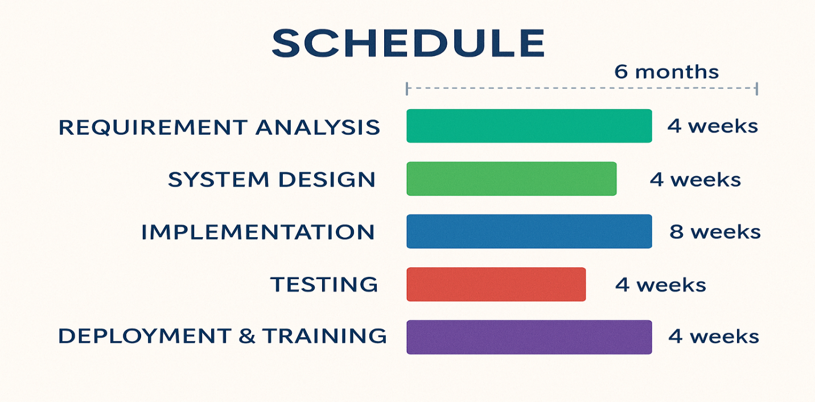

Figure 1: Gantt chart
CHAPTER TWO

STUDY OF EXISTING SYSTEM

2.1. Introduction

In this chapter, the previous system of DTU HRMS was clearly defined by answering several key questions: How did the existing system work? In what way were employees managed? What techniques were used to handle personnel files? What were the business rules of the existing system? And what were the problems in the existing system? After studying the existing system, it was possible to understand how the proposed system could solve the existing system's problems. Studying the existing system was also used to determine both functional and non-functional requirements.

2.2 Existing System Description

The previous Human Resource Management System (HRMS) at Debretabor University operated primarily through manual processes, which presented several significant challenges and limitations. This traditional approach encompassed various functions such as employee record management and recruitment, all of which were conducted without the support of a computerized or web-based system.
Key challenges of previous manual system
Time-Consuming Processes: The reliance on manual record-keeping necessitated extensive time and effort from HR personnel. Tasks such as data entry, document management, and information retrieval were often inefficient.
- Increased Security Risks: The manual system posed inherent security vulnerabilities. Physical documents were susceptible to loss, theft, or damage, which compromised the confidentiality of sensitive employee information.
- Limited Accessibility and Collaboration: A manual HRMS restricted accessibility to information, as data was often stored in physical files or isolated systems.
- Difficulty in Data Analysis and Reporting: Generating reports and analyzing employee data was a labor-intensive process in the manual system.

2.2.1. Players of previous system
The existing Human Resource Management System (HRMS) at Debretabor University involves several key players, each with specific roles and responsibilities that contribute to the overall functioning of human resource processes within the institution. Understanding these players is essential for identifying how the current system operates and where improvements can be made.
- HR manager
The HR manager played a critical role in overseeing all employee-related activities and departmental communications. This individual is responsible for ensuring that HR policies and procedures are followed and that all documentation is compliant with institutional standards.
- Staff Workers
Staff workers were the employees who operate within the HRMS office. This team is responsible for executing various administrative tasks, including data entry, record management, and responding to employee inquiries.
- Sections/Departments
Each section or department within the university represented a distinct business unit that encompasses all employees associated with it. These departments may include academic divisions, administrative offices, and support services, each with unique HR needs and challenges.
- Applicants
Applicants were individuals seeking employment opportunities within the university. They represent a critical external player in the HRMS
- Employees
Employees were the individuals who work at the institution, encompassing a diverse range of roles, including lecturers, accountants, technicians, and administrative staff. Each employee contributes to the university's mission and operations.

2.2.2. Explanation of the business rule of the organization
BR1: To hire a new employee, the department in need had to write an application letter for their vacant position to the personnel department.
BR2: The vacant position was announced to external applicants on a notice board or in mass media for a consecutive period of 5 to 10 work days.
BR3: To be employed, applicants were required to bring a clearance letter from their previous employer.
BR4: When human resources hired a new employee for a requesting department, they had to send a letter containing all the new employee's full documents to that department.
BR5: Access to information depended on the authority of the user.
BR6: An employee was required to have a valid reason to apply for leave.
BR7: If an employee wanted to leave the institution for any reason, they had to first submit their application to the human resource department.
BR8: Before an employee could formally leave DTU, they were required to return all working materials to their respective department. Failure to do so resulted in the rejection of their departure request.

2.3. Proposed System Description

The proposed Human Resource Management System (HRMS) for Debretabor University was designed to address and eliminate the shortcomings of the existing manual system. By leveraging modern technology and best practices, this web-based system aimed to streamline HR operations, enhance user experience, and improve data management across the university.
Key features and functionalities
- Centralized Announcements and Communications
The proposed system included a centralized platform for posting announcements relevant to all employees. This feature was designed to facilitate effective communication of important updates.
- Streamlined Recruitment and Onboarding
The system automated the hiring process, enabling HR personnel to manage job postings, track applications, and conduct interviews more efficiently. For new hires, it facilitated the onboarding process by assigning them to their respective positions and providing necessary resources for smooth integration.
- Comprehensive Employee Profiles
each employee had a dedicated personal profile within the system, which stored essential information such as contact details and employment history. This centralized database allowed HR personnel to manage and update employee information easily, fostering better record-keeping and data accessibility.
- Work Experience Letter Management: The system featured a dedicated module for work experience verification this allowed employees to request official experience letters digitally, and enabled HR personnel to generate and approve standardized letters, eliminating manual paperwork and streamlining the process.
- Leave Management System
the proposed HRMS incorporated a robust leave management module that handled the entire leave process, from application to approval. Employees could submit leave requests electronically, while HR personnel could review, accept, or reject these requests efficiently.
- Advanced Search and Retrieval Functions
the system included powerful search capabilities, allowing users to quickly retrieve information about employees, job postings, and announcements. This functionality reduced the time spent searching for data and improved overall operational efficiency.
- User Management
The HRMS supported user management features that enabled designated personnel to add new users, update existing user information, and manage access rights.
- Report Generation System
to support decision-making, the proposed HRMS included a comprehensive report generation system. This feature allowed HR personnel to generate various reports on demand.

2.3.1. Purpose of the new system
The system provided the following benefits:
- Security: Because the system required verification through a login form, sensitive information was not accessed or modified by unauthorized users.
- Efficient retrieval of employee files: Since the system recorded each employee's information in the database, retrieving employee files from the database at any time was a straightforward process.
- Efficient employee data management: Using a database system prevented data loss. Employee information was highly secured, and searching for or updating records was simple.
- Online information registration: The system provided online information about vacant positions to applicants, allowing them to see the required criteria and register online immediately.
- Notification information: The system provided notifications through posts on the website.

CHAPTER THREE

SOFTWARE REQUIREMENT SPECIFICATION

3.1. Introduction

The Software Requirement Specification (SRS) document provided a comprehensive description of the intended software system. It served as a foundational reference for both the development team and stakeholders, ensuring that the final product met the specified needs and expectations.
This chapter outlined the functional and non-functional requirements of the proposed Human Resource Management System (HRMS) for Debretabor University. It detailed the necessary features, constraints, and user interactions that guided the development process. By clearly defining these requirements, we aimed to create a system that enhanced operational efficiency, supported effective human resource management, and provided a user-friendly experience.
The SRS was structured to cover various aspects, including:
- Functional Requirements: Specific functionalities that the system was required to support, such as user management, leave management, and reporting.
- Non-Functional Requirements: Attributes such as performance, security, usability, and scalability that the system needed to adhere to.
- System Interfaces: Descriptions of how the HRMS would interact with other systems or components.
- User Requirements: Information on the needs and expectations of different user roles, including HR personnel, employees, and applicants.

3.2. General Constraints

In the development of the Human Resource Management System (HRMS) for Debretabor University, several general constraints had to be considered to ensure that the project aligned with institutional policies, technical limitations, and user expectations. These constraints could impact the design, implementation, and deployment of the system. The following were the key general constraints:
- Regulatory Compliance: The HRMS had to comply with relevant laws and regulations regarding data protection and privacy, such as the General Data Protection Regulation (GDPR) or local employment laws.
- Budget Limitations: The project was subject to a predefined budget, which limited the resources available for development, testing, and deployment. Cost-effective solutions had to be prioritized without compromising quality.
- Time Constraints: The development and deployment of the HRMS had to adhere to a specified timeline, which was influenced by the university's academic schedules.
- Technical Infrastructure: The HRMS had to operate within the existing IT infrastructure of Debretabor University, including its hardware, software, and network capabilities.
- User Skill Levels: The system design had to take into account the varying levels of technical proficiency among users. The HRMS needed to be user-friendly to ensure broad adoption.
- Security Requirements: The system had to implement stringent security measures to protect sensitive employee information from unauthorized access, data breaches, and cyber threats. This included user authentication, data encryption, and regular security audits.
- Scalability: The HRMS was designed to accommodate future growth in the number of users and data volume, allowing for easy scalability as the university expanded or as HR functions evolved.
- Maintenance and Support: Consideration was given to the ongoing maintenance and support of the system, including the availability of technical support staff and resources for troubleshooting and system updates.

3.3 Specific Requirements

3.3.1. External interface Requirements

The external interface requirements outlined how the Human Resource Management System (HRMS) would interact with users, hardware, software, and communication systems. These interfaces were crucial for ensuring seamless integration and a positive user experience.

3.3.1.1. User interfaces

The user interface (UI) of the HRMS was designed to be intuitive and user-friendly, catering to various user roles, including HR personnel, employees, and applicants. Key features included:
- Web-Based Accessibility: The HRMS was accessible via web browsers on various devices, including desktops, tablets, and smartphones.
- Dashboard: A central dashboard provided users with an overview of key metrics, notifications, and quick access to essential functions.
- Forms and Wizards: User-friendly forms for tasks such as leave applications, employee onboarding, and report generation utilized wizards to guide users through the processes.
- Search Functionality: Advanced search options allowed users to quickly find employee information, announcements, and reports.
- Help and Support: Contextual help features, tooltips, and user guides were integrated to assist users in navigating the system.

3.3.1.2. Hardware interface

The HRMS was designed to operate on standard hardware components, ensuring compatibility with the existing infrastructure. Key hardware interface requirements included:
- Server Requirements: The system was hosted on a dedicated server with sufficient processing power, memory, and storage to handle the expected user load and data volume.
- Client Devices: Users accessed the HRMS through personal computers, laptops, tablets, and smartphones. The system required minimal client specifications to ensure optimal performance.

3.3.1.2. Software interface

The HRMS was designed to interact with various software applications and systems to ensure functionality and data integrity. Key software interface requirements included:
- Database Management System (DBMS): The HRMS utilized a robust DBMS (MongoDB) for storing and managing employee data, which ensured efficient data retrieval and security.
- Authentication Systems: The system was integrated with the university's existing user authentication framework to streamline user access and enhance security.

3.3.1.3. Communication interface

The HRMS employed various communication interfaces to facilitate data exchange and user interaction. Key requirements included:
- Network Protocols: The system used standard internet protocols (HTTP/HTTPS) to enable secure communication between the client and server.

3.4. Functional Requirements

The functional requirements specified the essential functionalities that the Human Resource Management System (HRMS) was required to provide to meet user needs and support HR processes at Debretabor University. These requirements were categorized based on user roles and system capabilities.

3.4.1. User Management
FR-1.1 (User Registration): The system allowed HR administrators to create new user accounts for employees and applicants.
FR-1.2 (User Authentication): The system required users to authenticate with a unique username and password to access its features.
FR-1.3 (Roles and Permissions): The system supported distinct user roles (e.g., HR Admin, Employee, Department Head, and Applicant) and enforced role-based access controls.

3.4.2. Employee Management
FR-2.1 (Employee Profile Creation): The system enabled HR personnel to create and manage detailed employee profiles containing personal information, qualifications, and employment history.
FR-2.2 (Profile Self-Service): Employees could update specific personal information, such as contact details, through their own profiles.

3.4.3. Recruitment and Onboarding
FR-3.1 (Job Posting Management): The system allowed HR personnel to create, publish, and manage online job postings.
FR-3.2 (Application Tracking): The system tracked candidate applications, enabling HR to review, shortlist, and manage the recruitment pipeline.
FR-3.3 (Onboarding): The system facilitated the new employee onboarding process by managing required documentation and task lists.

3.4.4. Leave Management
FR-4.1 (Leave Request): Employees could submit electronic leave requests through the system.
FR-4.2 (Leave Approval Workflow): The system routed leave requests to the appropriate manager or HR personnel for electronic review and approval/rejection, with status notifications sent to the employee.

3.4.5. Work Experience Management
FR-5.1 (Letter Request): Employees could formally request an official work experience letter through the system.
FR-5.2 (Letter Generation & Approval): HR administrators could review requests, generate standardized digital experience letters, and approve them for official issuance.

3.4.6. Reporting
FR-6.1 (Report Generation): The system provided HR personnel with the ability to generate predefined reports (e.g., employee roster, leave summaries, recruitment status).

3.4.7. Notification System
FR-7.1 (Automated Notifications): The system sent automated notifications and alerts to users for events such as leave request updates, new announcements, and application status changes.

3.4.8. Data Security
FR-8.1 (Data Encryption): The system implemented encryption for sensitive employee data both during transmission (HTTPS) and while at rest in the database.

Use Case Design

Use case design was a critical aspect of the Software Requirement Specification, providing a clear understanding of how users (actors) would interact with the Human Resource Management System (HRMS). This section outlined the identification of actors and use cases, which served as a foundation for system functionality and user interactions.

3.5.1. Actor identification
Actors are individuals or systems that interact with the HRMS to perform specific tasks. Identifying these actors helps define the scope of the system and its functionalities. The primary actors for the HRMS include:
- HR manager: Responsible for managing various human resource functions, including employee records, recruitment, performance evaluations, and policy administration. They are the primary users of the system, interacting with it to perform daily HR tasks.
- Employees: University staff members who utilize the HRMS to access their personal profiles, submit leave requests and also view announcements.
- Applicants: Individuals seeking employment at the university. They interact with the HRMS primarily during the recruitment process, submitting applications and tracking their status. Their experience is crucial for attracting talent to the institution.
- Department Heads: users with departmental level access rights(managing employees, attendance tracking, accept or reject leave request )

3.5.2. Use case identification
Use cases described the specific functionalities and interactions that actors would have with the HRMS. Each use case represented a goal that an actor wanted to achieve through the system. The following key use cases were identified:
  - User Registration and Authentication
Actors Involved: HR Manager, Employees, Applicants
Description: This use case allowed users to create accounts and securely log in to the HRMS. It established the foundation for user access and security.
  - Employee Profile Management
Actors Involved: HR Manager, Department Head
Description: HR managers could create and update employee profiles, while employees could view and update specific sections of their personal information.
  - Job Posting and Application Management
Actors Involved: HR Manager, Applicants
Description: HR managers could post job openings and manage the recruitment pipeline. Applicants could submit applications and monitor their status.
  - Leave Application and Approval
Actors Involved: Employees, HR Manager
Description: Employees could submit electronic leave requests, which HR managers could review, approve, or reject through a managed workflow.
  - Work Experience Letter Management
Actors Involved: Employees, Department head and HR Manager
Description: Employees and department head could formally request an official work experience letter. HR managers could review these requests, generate standardized digital letters, and approve them for issuance.
  - Report Generation
Actors Involved: HR Manager
Description: HR managers could generate various reports related to employee data, leave statistics, and recruitment status. This functionality aided in data analysis and decision-making.

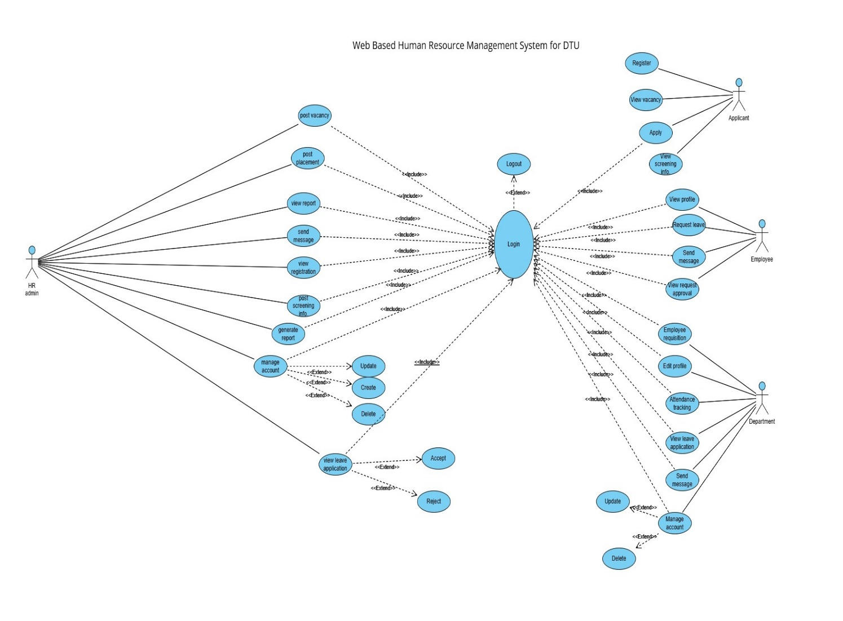
Figure 2: Use Case Diagram

3.5.3. Use case description
- Use case Name: Login
UC_ID: UC_01
Actor: Users (Human Resource Manager, Department Head, Employee)
Description: This use case described the process for securely authenticating and logging into the system.
Precondition: The user was required to have a valid username and password.
Post condition: Upon successful login, the system's main dashboard was displayed, granting the user access according to their privileges. The user could then log out upon completing their tasks.

Flows of event (main course of action):
Actor action | System response
Step1: User has to open the system.  Step3: by selects account type user fills his or her username and password.  Step4: click login button.  Step6: the User gets access the system. | Step2: The System displays the login interface and allows the user for the user name and password.  Step5:display login successful  Step7: displays its main window.  Step8: Use case ends.

Table 3: Main Course of Action about Login
Alternative Course of Action:
If the user entered invalid credentials:
The system displayed an error message indicating an incorrect username or password.
The system prompted the user to re-enter their credentials to try logging in again.

- Use case Name: employee requisition
UC_ID: UC_02
- Actor: department officer
- Description: This use case enables to submit employment requisition form for section/Dept. recruitment.
- Precondition: the user must login to the system.
- Post condition: requisition is saved to the database and successful message should be display for the user
Actor action | System response
Step1: click requisition page from menu  Step3: fill all information needed to the vacant position.  Step 4:click apply button | Step2: display requisition form  Step5: display successfully posted message.  Step7: finish requisition and the use case end

Table 4: Main Course of Action about employee requisition
Alternative course of action:
  - If the user doesn’t have access privilege to use the system, user is not authenticated and is denied access to the system.
- Use case Name: post announcement
UC_ID: UC_03
- Actor: human resource administrator
- Description: After section/department asks the employment requisition the human resource administrator should be posted vacancy announcement to get the worker.
- Precondition: the user must login to the system and the department should apply for employee.
- Post condition: Record is successfully added to the database message should be display for the user.

Actor action | System response
Step1: click post announcement page from menu  Step3: fill all information needed to the vacant position.  Step 4:click post button | Step2: display post announcement form  Step5: display successfully posted message.  Step7: finish posting announcement and the use case end

Table 5: Main Course of Action about post announcement
Alternative course of action:
  - If the user doesn’t have access privilege to use the system; user is not authenticated and is denied access to the system.
- Name: register applicant online
UC_ID: UC_04
- Actor: applicant
- Description: this use case is done by the applicant in order to register for applying to the vacant position.
- Preconditions: he/she must have an internet connection, and must have necessary information based on the announcement requirements.
- Post conditions: the applicant must be registered successfully.
- Exceptional condition: if there is no internet connection there is no registration.

Actor action | System response
Step 1: the applicant opens the home page of the website.  Step 3: Select vacancy page  Step 5: fill all his/her information required.  Step 5:click apply button | Step2 : the system display the home page  Step4: the system display the applicant registration form  Step6: the system display register successfully message
Table 6: Main Course of Action about registering applicant online
Alternative course of action:
  - The system display register failed message if there is unfilled information in the form.
- Use case Name: placement
UC_ID: UC_05
- Actor: human resource administrator
- Description: the human resource administrator will record the new employed applicant’s information and place them to their position.
- Precondition: the human resource must login to record and place the new employed applicant information.
- Post condition: display registration and placement.
Actor action | System response
Step1: click the placement and registration page from menu  Step3: fill the all employee information and place to their position.  Step 4:click submit button | Step2: display placement and registration page  Step5:display save successful message  Step7: finish placement and the use case end

Table 7: Main Course of Action about placement
- Use case Name: Manage employee
UC_ID: UC_06
- Actor: department
- Description: This use case is done by the department when they need update search and delete employee profile information
- Preconditions: The department must login to the system to manage employee.
- Post conditions: The employee information will be managed (searched, updated) by department.

About updating employee information:
Actor action | System response
Step 1: the department click manage employee link  Step3: the department enter the id number of the employee to update  Step 5: the department fill the new updated information of the employee.  Step 6:click submit button | Step2: the system display the manage employee page  Step4: the system display the update form with the registered employee information  Step7: display update successful page

Table 8: Main Course of Action about Update employee
Alternate course action:
  - The system display error message if the employee information doesn’t fill accurately.
About searching employee information
Actor action | System response
Step 1: the department click manage employee link  Step 3: the department enters the id number of the employee to search and click search button. | Step2 : the system display mange employee page  Step4: the system display the employee information  Step8: finished searching and stop the use case

Table 9: Main Course of Action about searching
Alternate course action:
  - The system displays fill again message to department if the entered id is incorrect.
About deleting employee information

Actor action | System response
Step 1: the department officer click manage employee link  Step 3: the department officer enters the id number of the employee to search and click search button.  Step 5:the administrator enter delete button | Step2 : the system display mange employee page  Step4: the system display the employee information  Step6: the system display delete successful message and stop the use case

Table 10: Main Course of Action about deleting employee
Alternate course action:
- The system displays fill again message to department officer if the entered id is incorrect.
- The system display deletion failed if the entered data are not available

- Use case Name: apply leave
UC_ID: UC_07
- Actor: employee
- Description: This use case is done by the employee when they want to leave from the institution.
- Precondition: the user must login to the system and must have full reason to apply leave.
- Post condition: The employee application will be saved to the database.
Actor action | System response
Step1: click leave application page  Step3: fill all information needed to apply  Step 4:click apply button | Step2: display leave application form  Step5: display successful message.  Step7: finish apply and the use case end

Table 11: Main Course of Action about apply leave
- Use case Name: send employee leave
- UC_ID: UC_8
- Actor: department
- Description: This use case is done by the department to apply employee leave application to the human resource admin.
- Precondition: the user must login to the system and must accept employee leave accept.
- Post condition: The department application will be saved to the database.
Actor action | System response
Step1: click leave application page from menu  Step3: fill all information needed to apply employee leave.  Step 4:click apply button | Step2: display leave application form  Step5: display successfully applied message.  Step7: finish applying and the use case end

Table 12: Main Course of Action about send employee leave application
Alternative course of action:
  - If the user doesn’t have access privilege to use the system; user is not authenticated and is denied access to the system.
- Use case Name: approve leave application
- UC_ID: UC_9
- Actor: human resource manager
- Description: after the department applies the leave application of employee to the human resource admin the human resource admin will view and approve their application.
- Precondition: the user must login to the system
- Post condition: application is viewed and display successfully approved message to the user.
Actor action | System response
Step1: click view leave application page from menu  Step3:read the reason for applying leave  Step4:check leave status  Step5: approve the leave application. | Step2: display leave application page  Step6: finish approving and the use case end

Table 13: Main Course of Action about approve leave application
Alternative course of action:
  - If the user doesn’t have access privilege to use the system, user is not authenticated and is denied access to the system.
- Use case Name: notification
- UC_ID: UC_10
- Actor: human resource manager
- Description: human resource admin after viewing leave application he/she notify the result for the leave application to the employee.
- Precondition: the actor must login to notify the result and the employee must have an email address
- Post condition: The applicant employee must be notified
Actor action | System response
Step1: click notification page from menu  Step3: fill the notification  Step 4:click send button | Step2: display notification page Step5:display sent successful message  Step6: finish notification and the use case end

Table 14: Main Course of Action about notification

- Use case Name: generate report
UC_ID: UC_11
- Actor: human resource manager
- Description: human resource admin will generate report to the necessary activities
- Precondition: the user must login to the system
- Post condition: application is viewed and display successfully approved message to the user.
Actor action | System response
Step1: User clicks the generate report menu.  Step3:The user fill the form  Step4: The user clicks on report type menu item | Step2: The system display report form  Step6: The system displays successful message and the use case end

Table 15: Main Course of Action about report
- Use case Name: Attendance track
UC_ID: UC_11
- Actor: department head
- Description: department head will track the attendance of the employees
- Precondition: the user must login to the system
- Post condition: successful message to the user

Actor action | System response
Step1: User clicks the attendance menu.  Step3:The user fill the filed manually  Step4: The user clicks on save button | Step2: The system display employees list with a field to fill the attendance  Step6: The system displays successful message and the use case end
Table 16: main course of action about attendance tracking
- Use case Name : work experience letter request
UC-ID: UC-12
Actor: Employee or Department Head
Description: employee or Department Head will request a work experience letter
Precondition: the user must be login to the system
Post condition: successful message to the user
Actor actions | System response
Step 1: user click work experience from menu  Step 3: the user fill the form  Step 4: the user click submit | Step 2: the system display the form to submit the request  Step 5: the system shows successful message

3.6. Sequence diagram
A Sequence diagram is an interaction diagram that shows how processes operate with one another and in what order. It is a construct of a message sequence chart. A sequence diagram shows object interactions arranged in time sequence. It depicts the objects and classes involved in the scenario and the sequence of messages exchanged between the objects needed to carry out the functionality of the scenario.

Figure 3: Sequence Diagram for Login

Figure 4: sequence diagram for employee requisition

Figure 5: sequence diagram for post announcement

Figure 6: sequence diagram for view and register
Figure 7: sequence diagram for placement

Figure 8: sequence diagram for apply leave

3.7. Activity diagram

Activity diagrams are graphical representations of workflow of stepwise activities and actions with support for choice, iteration and concurrency. In the unified modeling language, activity diagrams are intended to model both computational and organizational processes (i.e. workflows). Activity diagrams show the overall flow of control.
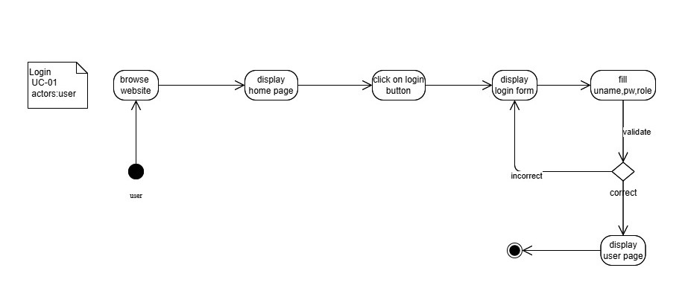
Figure 9: activity diagrams for login
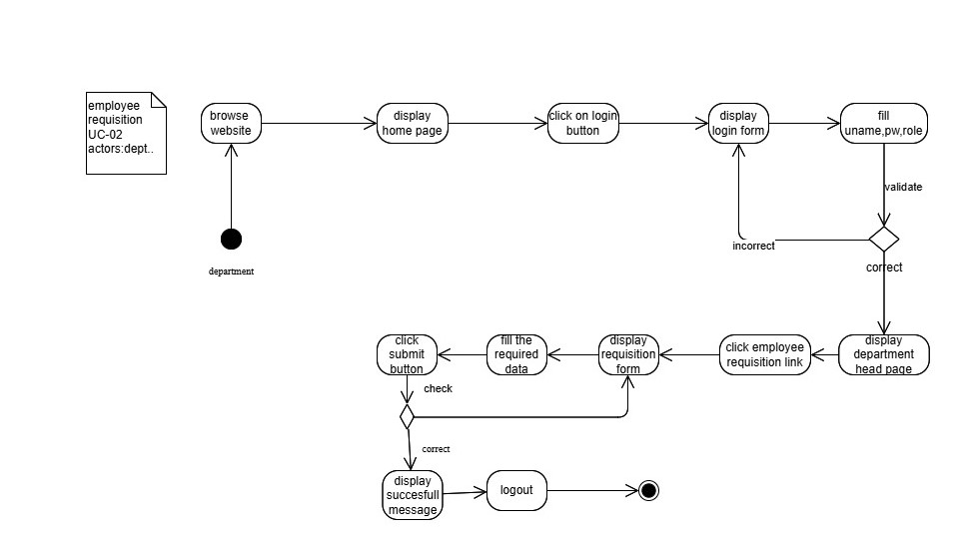
Figure 10: activity diagrams for employee requisition
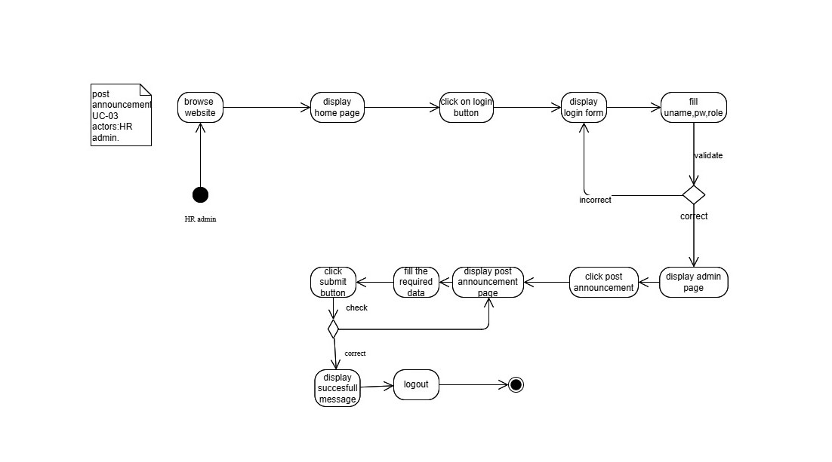
Figure 11: activity diagram for post announcement
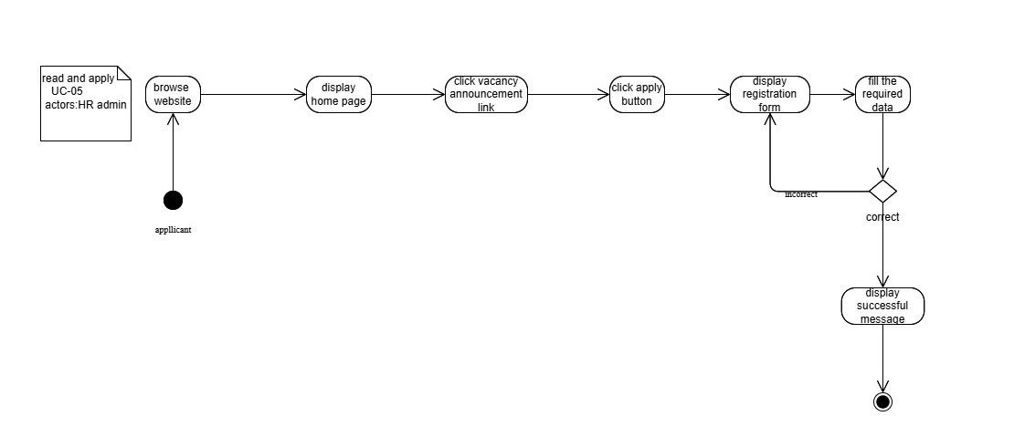
Figure 12: activity diagram for view and apply

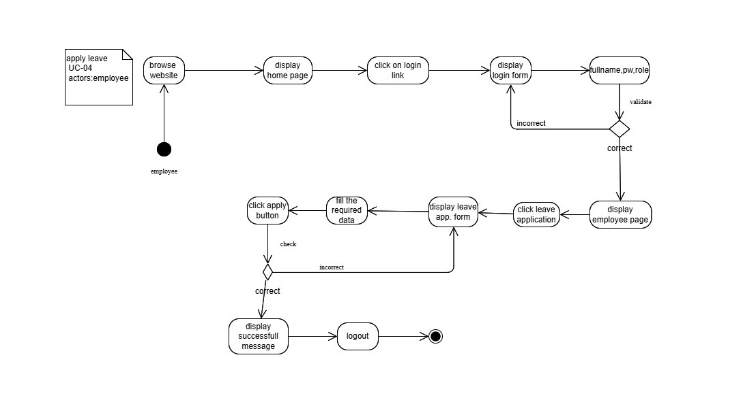
Figure 13: activity diagram for apply leave

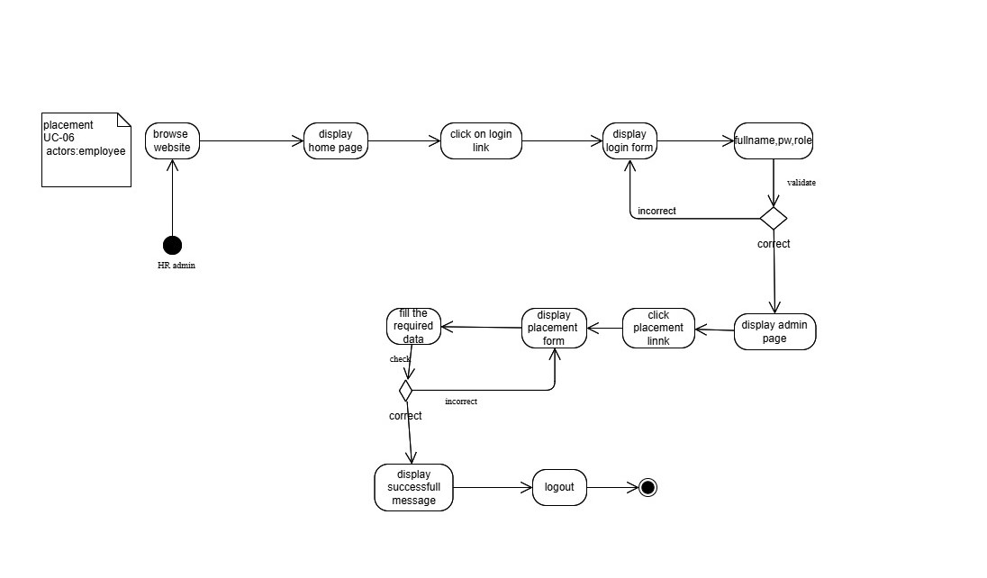
Figure 14: activity diagrams for placement

3.8. Class diagram

The class diagram is the main building block of object oriented modeling. It is used both for general conceptual modeling of the systematic of the application, and for detailed modeling translating the models into programming code. Class diagrams can also be used for data modeling the classes in a class diagram represent both the main objects, interactions in the application and the classes to be programmed.
In the diagram, classes are represented with boxes which contain three parts:
- The top part contains the name of the class. It is printed in bold and centered, and the first letter is capitalized.
- The middle part contains the attributes of the class. They are left-aligned and the first letter is lowercase.
- The bottom part contains the methods the class can execute. They are also left-aligned and the first letter is lowercase.
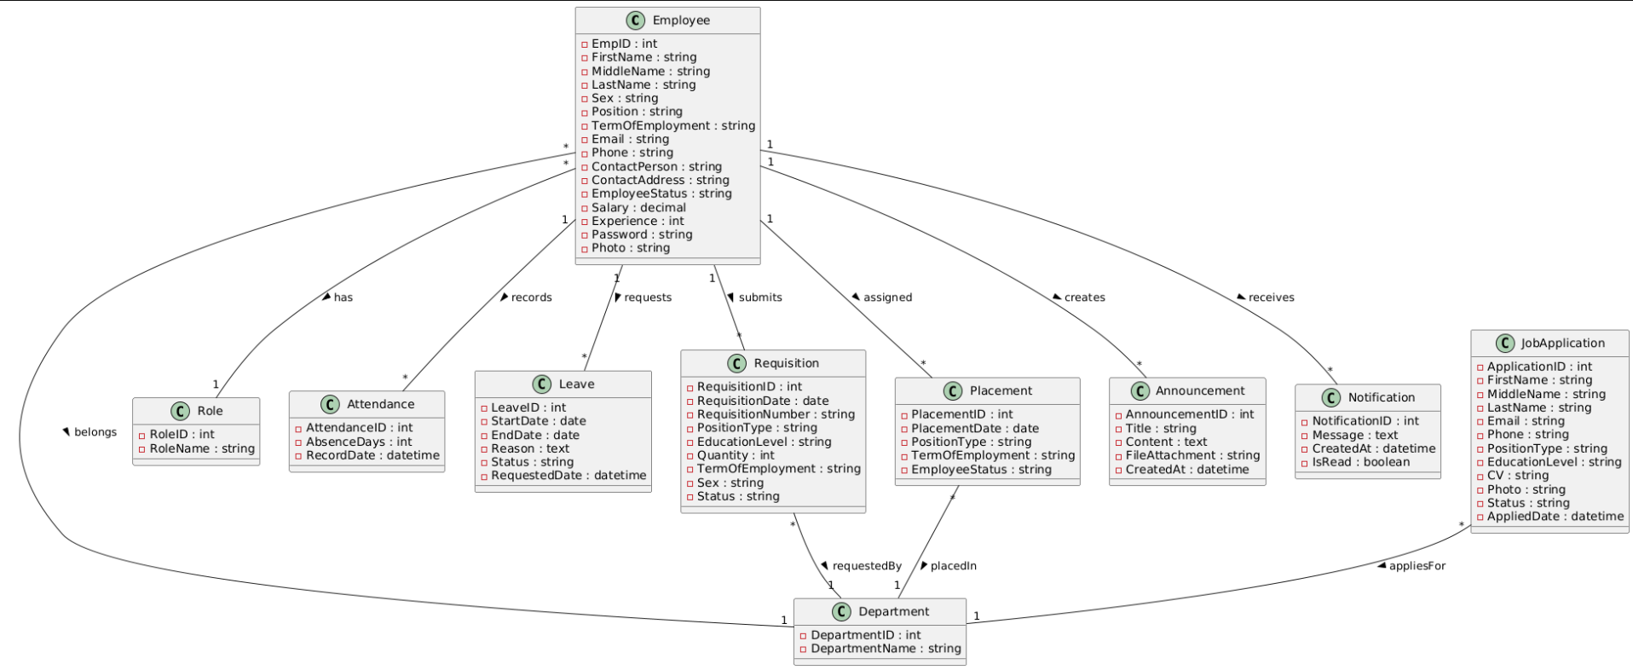
Figure 15: class diagram

3.9 Data Structural Model
The Data Structural Model outlines how data is organized and how relationships among data entities are structured within the Human Resource Management System (HRMS). A well-designed data model ensures efficient data management and retrieval, which is crucial for the system's functionality.

3.9.1. Entity relationship (ER) model
The Entity-Relationship (ER) Model is a conceptual framework that visually represents the data entities in the HRMS and their relationships. This model helps define how data is interconnected and supports the overall database design.
Key entities and attributes
- users - id, accounttype, email, username, password, signup_date
- applicant - apid, fname, mname, lname, age, cgpa, edu_level, sex, email, photo, scanfile
- screening - apid, fname, mname, lname, cgpa, rank
- evaluation - fname, mname, lname, age, cgpa, rank
- placement - date, fname, mname, lname, sex, emp_id, department, type, term, email, phone, contact_person, contact_person_address, salary, experience
- requisition - requisitiondate, requisitionnumber, typeposition, department, edu_level, quantity, termofemployee, sex
- approve - requisitiondate, approvernumber, requisitionnumber, quantity, requestby, approvedby, approveddate
- leave_application - name, department, hr_id, leave_number, start_date, end_date, leave_reason, email
- leave_approval - emp_id, leave_date, approvernumber, leave_number, approvedby, approved_date
- pm - id, hr_id, title, user1, user2, message, timestamp, user2read
- Department - dep_id
- HR_admin - hr_id
- schedule - date, jobnumber, writtendate, examdate, examtime, placedate, placetime, remember
- announcement - date, jobno, typeposition, dep_id, edu_level, salary, termofemployee, department, enddate, remember
- comment - fname, email, date, comment
- employee - emp_id
- attendance -att_id: integer,emp_id: varchar,absence_days: integer,remark: varchar,notify: Boolean,updated_at: date
Relatinships
- Users → PM 1:N — One user can send/receive many messages.
- Users → Comment 1:N — One user can post many comments.
- Applicant → Screening 1:1 — One applicant has one screening record.
- Applicant → Comment 1:N — One applicant can receive many comments.
- Applicant → Evaluation 1:1 — One applicant has one evaluation.
- Requisition → Approve 1:1 — One requisition has one approval record.
- Department → Requisition 1:N — One department can submit many requisitions.
- Department → Announcement 1:N — One department can be associated with many announcements.
- HR Admin → Announcement 1:N — One HR Admin can post many announcements.
- HR Admin → Placement 1:N — One HR Admin can place many employees.
- HR Admin → Leave Application 1:N — One HR Admin can handle many leave applications.
- Schedule → Announcement 1:N — One schedule is linked to many announcements.
- Leave Application → Leave Approval 1:1 — One leave application has one approval record.
- Employee → Placement 1:1 — One employee has one placement record.
- Employee → Leave Application 1:N — One employee can submit many leave applications.
- Employee → Leave Approval 1:N — One employee can have multiple approved leaves.
- Employee → Attendance 1:N — One employee can have many attendance records.
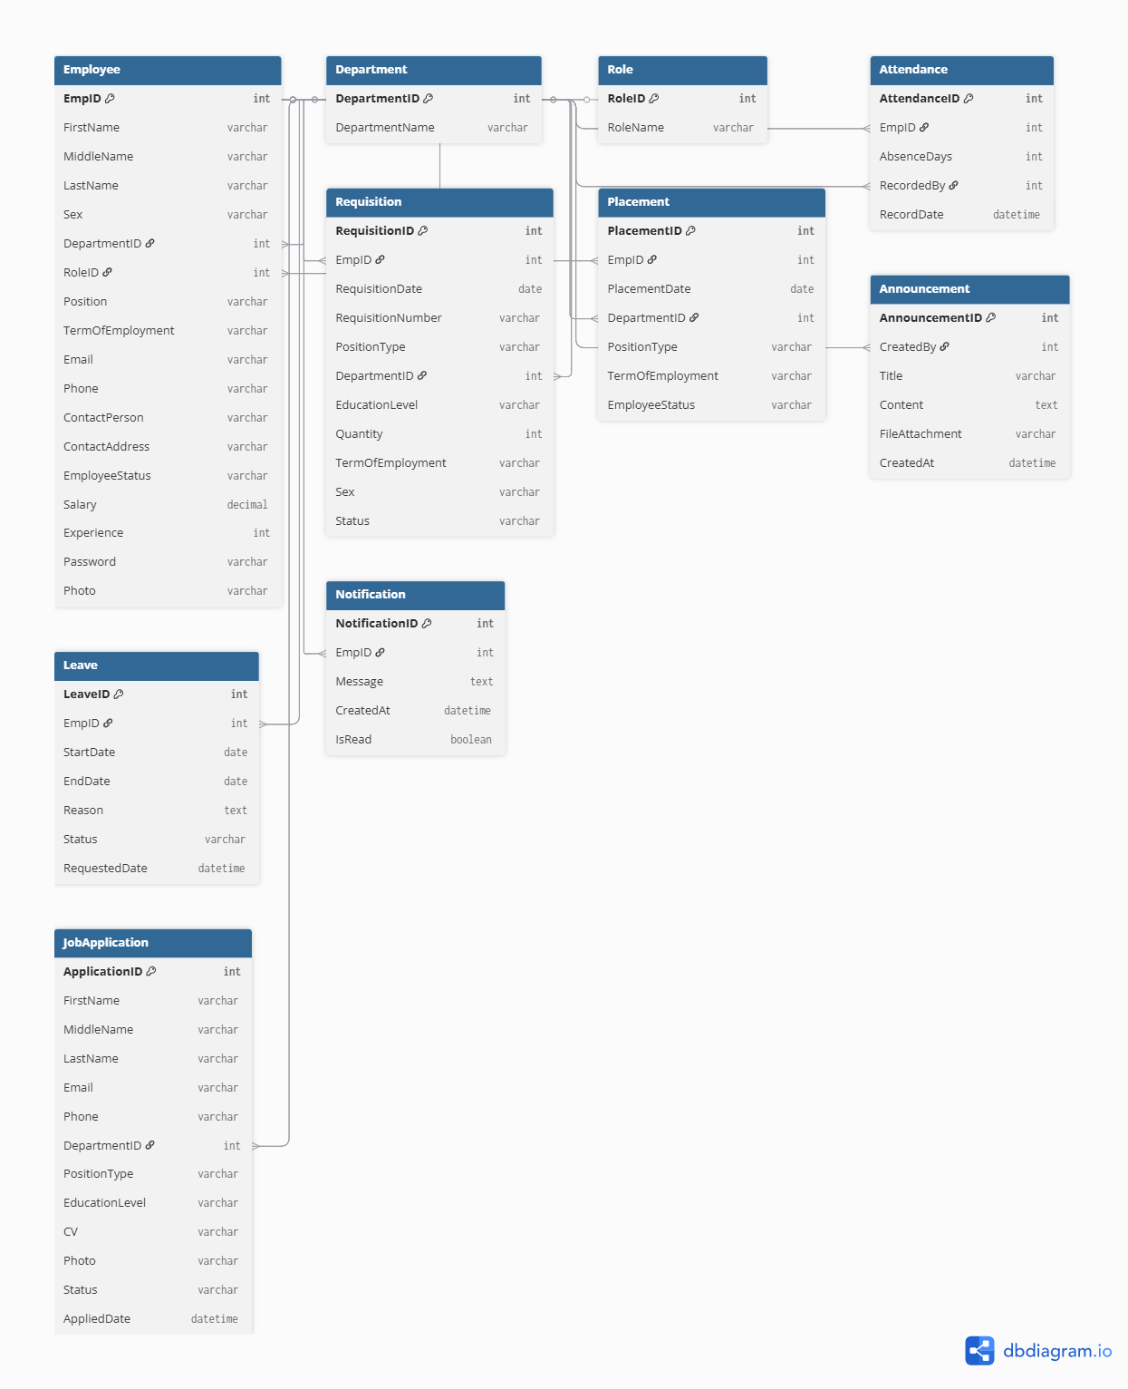
Figure 16: Entity relationship (ER) diagram

3.10 Non-Functional Requirements
Non-functional requirements are critical to the overall quality and performance of the Human Resource Management System (HRMS). They define how the system performs its functions and ensure that it meets user expectations in terms of reliability, security, and usability. Below is a broader overview of the key non-functional requirements for the HRMS.

3.10.1. Performance
Performance requirements were essential for ensuring that the HRMS operated efficiently, particularly during peak usage times.
- Response Time: The system was required to provide quick responses to user requests, with a target of processing actions within a maximum of 2 seconds during high-load periods. This responsiveness was crucial for maintaining user satisfaction and productivity.
- Throughput: The HRMS needed to support a minimum of 100 concurrent users performing various tasks simultaneously without noticeable performance degradation. This capability was vital for accommodating the university's staff and management needs.
- Data Processing: The system was required to efficiently handle data retrieval and processing, ensuring that search queries for employee records returned results in under 3 seconds. This enhanced the user experience, particularly for HR personnel who required quick access to information.

3.10.2. Reliability
Reliability is a measure of the system's ability to consistently perform its intended functions without failure.
- Error Rate: The HRMS was required to maintain an error rate of less than 1% across all transactions and operations. This reliability was essential to build trust among users and ensure smooth HR processes.
- Transaction Integrity: All transactions processed by the system were required to be completed successfully or rolled back in the event of an error, ensuring that data integrity was preserved at all times. This requirement was critical for maintaining accurate employee records.
- System Recovery: In case of unforeseen failures, the system was designed to recover and restore normal operations within 15 minutes. This quick recovery time minimized disruptions to HR activities and maintained operational continuity.

3.10.3. Availability
Availability requirements ensure that the HRMS is accessible to users when needed.
- Uptime: The system was required to guarantee an uptime of 99.9%, ensuring that it was consistently available for user access. High availability was crucial for supporting ongoing HR functions and employee needs.
- Maintenance Windows: Any scheduled maintenance had to occur outside of regular business hours to minimize disruption to users. Advance notifications were provided to ensure users were aware of potential downtime.

3.10.4. Security
Security is paramount in protecting sensitive employee information and maintaining compliance with data protection regulations.
- Data Protection: The system was required to implement robust encryption methods for protecting sensitive data both during transmission and while stored. This was essential to safeguard personal information from unauthorized access and breaches.
- User Authentication: The HRMS required user authentication through a login system, enhancing security by verifying user identity before granting access to the system.
- Access Control: Role-based access controls were enforced, ensuring that users could only access the information and functionalities necessary for their specific roles. This minimized the risk of data exposure and unauthorized actions.

3.10.5. Maintainability
Maintainability ensures that the HRMS can be easily updated and supported over time.
- Modular Design: The system was designed in a modular manner, allowing for individual components to be updated or maintained without impacting the overall system. This design facilitated easier enhancements and troubleshooting.
- Documentation: Comprehensive documentation was provided, including user manuals, technical specifications, and troubleshooting guides, to support ongoing maintenance efforts. Clear documentation was crucial for both users and technical support staff.
- Error Logging: The HRMS included mechanisms for logging errors and system events, enabling quick identification and resolution of issues as they arose. This logging capability was essential for effective system maintenance and user support.

3.10.6. Portability
Portability requirements ensure that the HRMS can operate across various environments and platforms.
- Cross-Platform Compatibility: The system was required to be compatible with multiple operating systems, including Windows, macOS, and Linux, as well as various devices such as desktops, tablets, and smartphones. This flexibility allowed users to access the HRMS from different environments.
- Cloud Deployment: The HRMS was designed to support deployment in cloud environments, enabling scalability and flexibility in resource allocation. Cloud deployment also facilitated easier updates and maintenance, as well as remote access for users.
By adhering to these non-functional requirements, the HRMS was designed to deliver a reliable, secure, and efficient solution that met the diverse needs of Debretabor University’s human resource management processes.

CHAPTER FOUR

SYSTEM DESIGN

4.1. Design overview

The design phase of the Human Resource Management System (HRMS) focused on translating the requirements gathered during the analysis phase into a structured solution. This chapter provides a comprehensive overview of the system architecture, components, and design principles that guided the development of the HRMS at Debretabor University.

4.1.1. Objectives of the System Design
- Modularity: The HRMS was designed as a set of interconnected modules, each responsible for specific functionalities. This modular approach allowed for easier maintenance, updates, and scalability.
- User-Centric Design: The system prioritized the needs of its users through an intuitive user interface and user experience design, ensuring ease of navigation and accessibility.
- Data Integrity and Security: Ensuring the security of sensitive employee data was paramount. The system implemented robust authentication and authorization mechanisms, as well as data encryption techniques to protect information.
- Scalability: The design accommodated future growth in terms of user load and feature expansion, ensuring that the system could evolve alongside the university's needs.

4.2. System architecture design

The HRMS utilized a three-tier architecture, which comprised:
- Presentation Layer: This layer was responsible for the user interface, enabling users to interact with the system.
- Business Logic Layer: This layer contained the core functionalities of the HRMS, processing user requests, enforcing business rules, and managing data flow between the other layers.
- Data Layer: The data layer managed the storage and retrieval of data. It implemented the Entity-Relationship (ER) model, ensuring data integrity and efficient access.

4.2.1 System Interface Description
The HRMS included several key interfaces that facilitated interaction between different components and users:
- User Interface:
This was the main interface for employees, HR personnel, and administrators. It provided access to functionalities such as profile management, leave applications, and reporting. The interface was designed to be user-friendly, ensuring easy navigation.
- API Interface:
The business logic layer exposed RESTful APIs for interaction with potential external systems. These APIs allowed for structured data exchange, enabling the HRMS to integrate with other applications effectively.
- Database Interface:
The data layer interacted with the database using Object-Relational Mapping (ORM) frameworks. This interface managed all CRUD (Create, Read, Update, and Delete) operations for employee records, leave applications, and other data entities.

4.2.2. Component Diagram
This diagram illustrated how the components of the system were connected, showing the relationships among them. It depicted the core system management modules, the database, and the operations performed, including security mechanisms. To some extent, it clarified which components or objects were accessible by different user roles and what type of security infrastructure was implemented.

Figure 17: component diagram

4.3. User Interface Design

4.3.1. Description of the User Interface
The user interface (UI) for the HRMS system was designed to be intuitive and user-friendly, ensuring that users could navigate the application easily. Key components of the UI included:
- Dashboard:
This served as a central hub, displaying key metrics such as employee counts, upcoming leave requests, and recent activities. Widgets provided quick access to various sections of the application.
- Navigation Menu:
A consistent menu allowed users to navigate between sections like Employees, Recruitment, Leave Applications, Work Experience, and Reports.
- Employee Management Page:
A dedicated page for adding, editing, and viewing employee details. It included a searchable table with filter options for efficient data access.
- Leave Application Form:
A user-friendly form for submitting leave requests. It included fields for start date, end date, leave type, and reason for leave.
- Responsive Design:
The UI was fully responsive, ensuring full functionality across devices such as desktops, tablets, and smartphones.

4.3.2 Screenshot Images
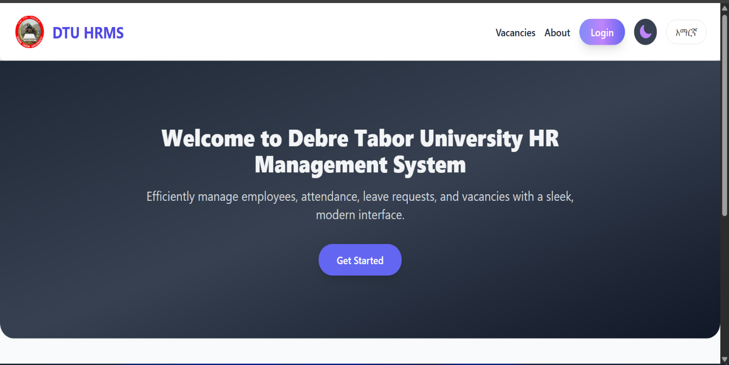
Figure 18: user interface for login

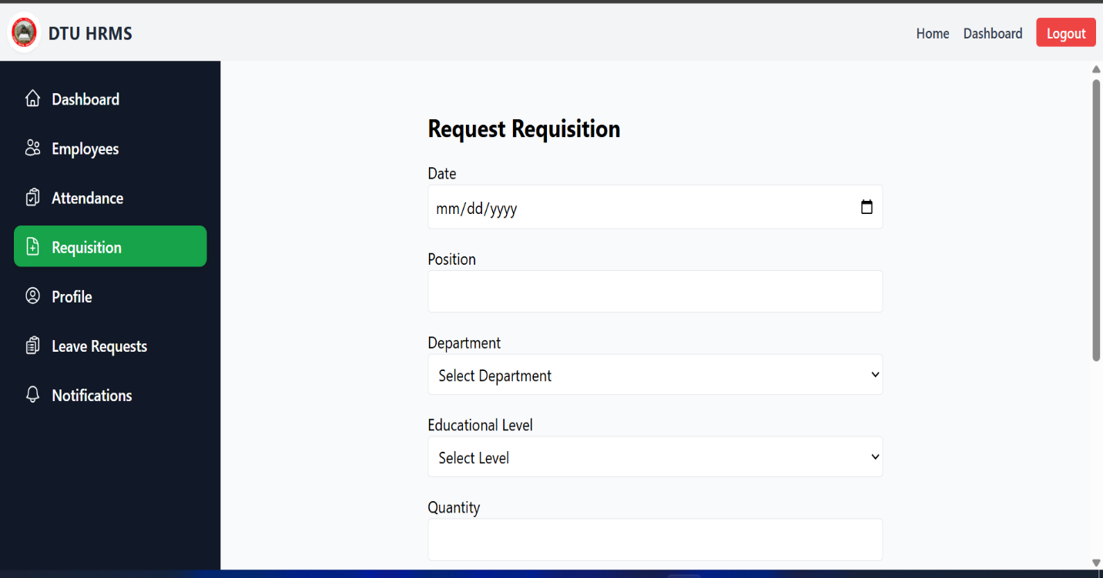
Figure 19: user interface for employee requisition

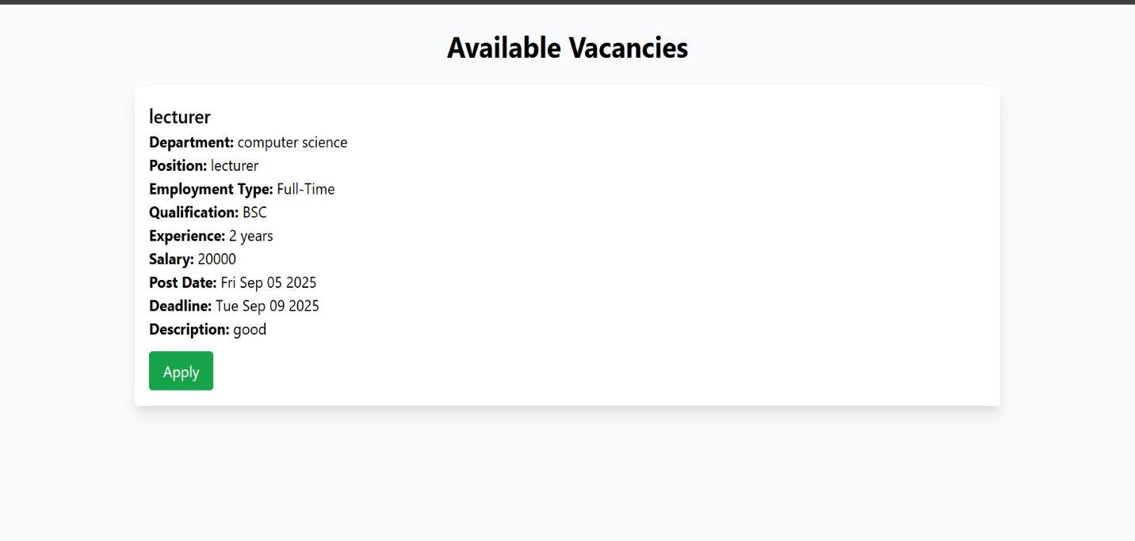

Figure 20: user interface for apply

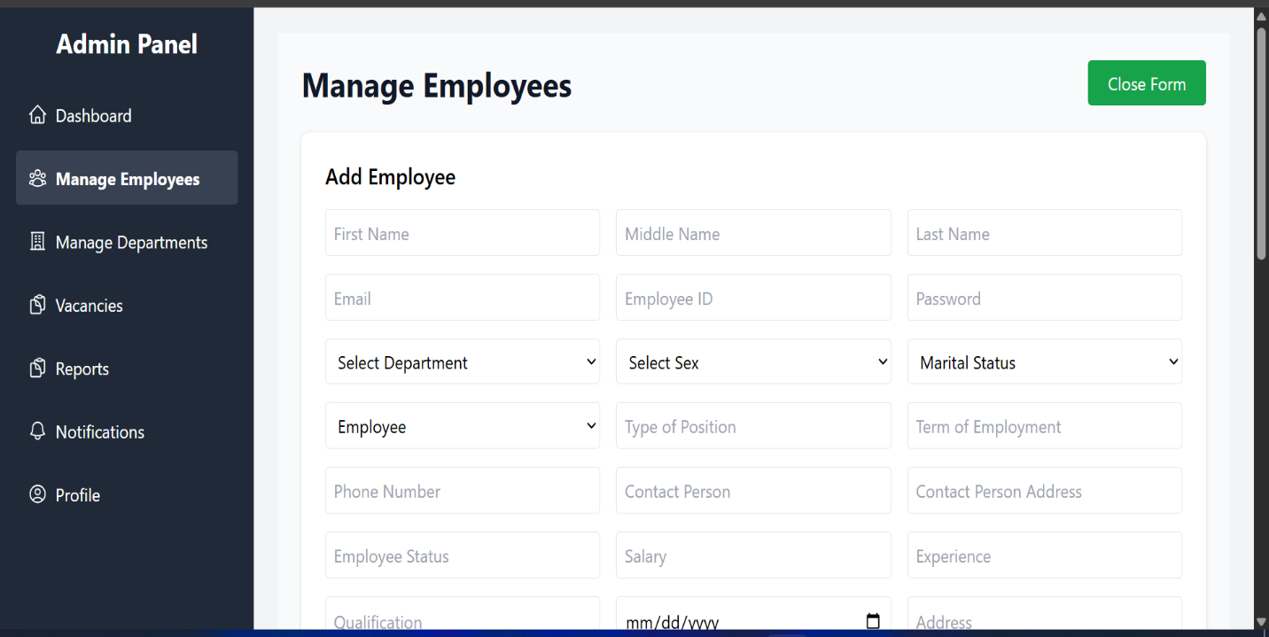

Figure 21: user interface for employee placement

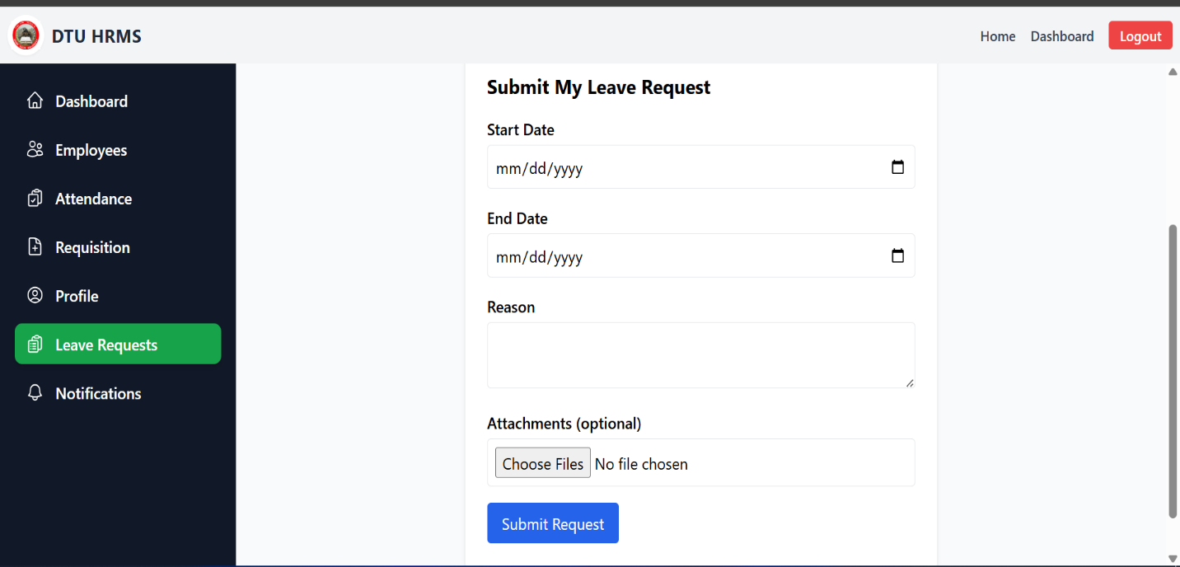
Figure 22: user interface design for leave application

4.4 Database Design

4.4.1 Persistent Database Design
Database design is the process of producing a detailed data model of a database. This logical data model contains all the needed logical and physical design choices and physical storage parameters needed to generate a design in a Data Definition Language, which can then be used to create a database. A fully attributed data model contains detailed attributes for each entity. The term database design can be used to describe many different parts of the design of an overall database system. Principally, and most correctly, it can be thought of as the logical design of the base data structures used to store the data.

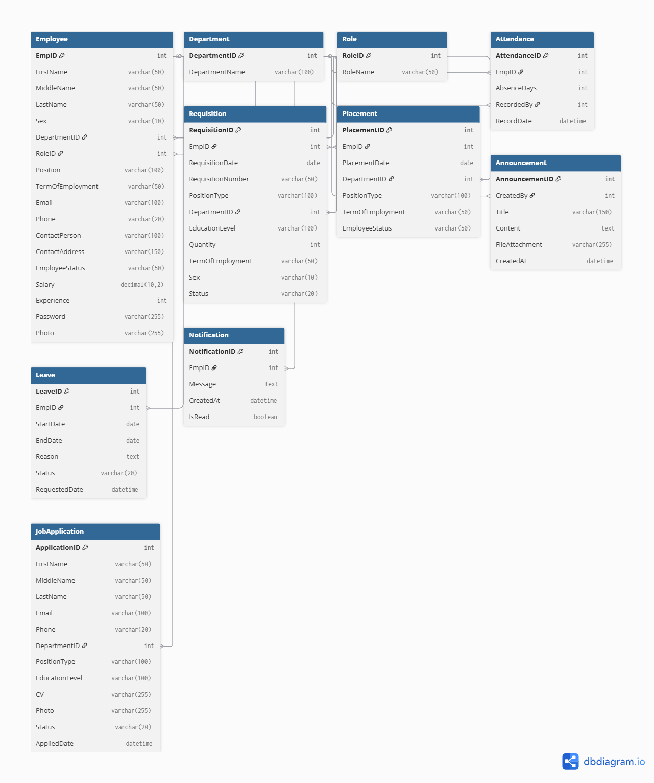
Figure 23: Data base design diagram

CHAPTER FIVE

SYSTEM TESTING

5.1. System overview
System testing was carried out to ensure that the Web-Based Human Resource Management System (HRMS) developed for Debre Tabor University operates according to the specified functional and non-functional requirements. This phase of the project focused on validating the correctness, reliability, usability, security, and performance of the system before deployment.
The HRMS was tested as a fully integrated system, combining the frontend user interfaces, backend application logic, database operations, and role-based access control mechanisms. Testing ensured that all system components interact correctly and that data is accurately processed and stored.
The major modules tested during this phase include user authentication and authorization, employee management, recruitment and vacancy management, leave management, attendance tracking, notification handling, and report generation. Each module was evaluated to confirm that it performs its intended functions and handles both valid and invalid inputs appropriately. Special attention was given to system security, data integrity, and user access permissions to prevent unauthorized actions.

5.2. Test approach
A structured and systematic testing approach was adopted to identify defects and verify that the system meets its design specifications. Both manual testing and limited automated testing techniques were used to achieve comprehensive coverage of system functionality.
The following testing levels were applied:
- Unit Testing: Individual system components such as frontend forms, backend API endpoints, and database models were tested independently to ensure that each unit performs its intended function correctly.
- Integration Testing: Interactions between system components were tested, particularly communication between the React frontend and the Node.js/Express backend, as well as data exchange with the MongoDB database.
- System Testing: The complete HRMS was tested as a single integrated solution to verify end-to-end functionality across all modules.
- User Acceptance Testing (UAT): Selected users, including HR personnel and employees, evaluated the system to confirm that it meets real-world operational requirements and is user-friendly.
A black-box testing technique was primarily employed, focusing on system behavior and outputs without considering the internal implementation details. This approach ensured that the system was tested from the end-user’s perspective.

5.3. Test Plan
The test plan outlines the scope of testing, testing methods, tools used, and the environment in which testing was conducted. It served as a guideline to ensure systematic and consistent testing throughout the system.

5.3.1. Features to be tested
The following core features of the HRMS were included in the testing scope:
- User login and authentication
- Role-based access control (HR Admin, Department Head, Employee, Applicant)
- Employee registration, update, and deletion
- Vacancy posting and job application submission
- Leave application, approval, and rejection processes
- Attendance entry and tracking by department heads
- Notification and alert system
- Report generation and viewing
- File upload and download functionalities (CVs and supporting documents)
- Multilingual support (English and Amharic)

5.3.2. Features not to be tested
Due to time and resource constraints, the following features were excluded from the testing scope:
- Stress testing with a very high number of concurrent users
- Cross-browser compatibility testing for older browser versions
- Reliability testing of third-party email services

5.3.3. Testing Tools and Environments
The testing environment and tools used are summarized as follows:
- Hardware: Personal computer (Intel Core i3 processor, 8GB RAM)
- Operating System: Windows 11
- Frontend Technologies: React.js with Tailwind CSS
- Backend Technologies: Node.js with Express.js
- Database: MongoDB
- Testing Tools:
  - Postman for API testing
  - Browser developer tools for frontend testing and debugging
  - Manual test cases and test scripts

5.4. Test Cases
A set of representative test cases was designed and executed to validate the major functionalities of the system.

Test Case 1: User Login
- Purpose: To verify that authorized users can successfully log into the system
- Inputs: Valid username, password, and selected user role
- Expected Output: User is authenticated and redirected to the appropriate dashboard
- Pass/Fail Criteria: Login completes successfully without error messages
Test Procedure:
- Open the system login page
- Enter valid login credentials
- Select the appropriate user role
- Click the login button
Test Result:
- Status: Passed

Test Case 2: Employee Registration
- Purpose: To verify employee creation by the HR Admin
- Inputs: Employee personal details and job-related information
- Expected Output: Employee record is saved in the database
- Pass/Fail Criteria: Employee appears in the employee list
Test Procedure:
- Log in as HR Admin
- Navigate to the Employee Management module
- Enter employee details
- Click the Save button
Test Result:
- Status: Passed

Test Case 3: Leave Application
- Purpose: To verify employee leave request submission
- Inputs: Leave type, start date, end date, and reason
- Expected Output: Leave request is submitted and notification is sent to HR Admin
- Pass/Fail Criteria: Leave request appears on the HR Admin dashboard
Test Procedure:
- Log in as an Employee
- Navigate to the Leave Application module
- Complete the leave request form
- Submit the request
Test Result:
- Status: Passed

Test Case 4: Vacancy Application
- Purpose: To verify the job application process for applicants
- Inputs: Applicant personal details and CV upload
- Expected Output: Application is stored and visible to HR Admin
- Pass/Fail Criteria: Application information is displayed correctly
Test Procedure:
- Open the vacancy announcement page
- Fill in applicant details
- Upload the CV file
- Submit the application
Test Result:
- Status: Passed

5.5. Summary of Test Results
All core functionalities of the Web-Based Human Resource Management System were tested and verified successfully. The testing process confirmed that the system operates as intended and meets the specified functional and non-functional requirements.
Minor user interface alignment issues were identified during testing; however, these issues were corrected promptly and did not affect overall system functionality. No critical defects remained unresolved at the end of the testing phase. Based on the testing results, the system is considered stable, reliable, and ready for deployment and practical use within Debre Tabor University.

CHAPTER SIX

CONCLUSION AND RECOMMENDATION

Conclusion
This project successfully designed and implemented a Web-Based Human Resource Management System (HRMS) for Debre Tabor University to overcome the limitations of the existing manual and semi-automated human resource management practices. The developed system effectively automates core HR functions, including employee registration and management, recruitment and vacancy handling, leave application and approval, attendance tracking, notification management, and report generation.
The use of the MERN stack (MongoDB, Express.js, React.js, and Node.js) enabled the development of a modern, scalable, and maintainable web application. The system provides a user-friendly interface, secure role-based access control, and efficient data management, ensuring that sensitive employee and institutional data are handled securely and accurately. By centralizing HR data in a single system, the HRMS reduces redundancy, minimizes human error, and significantly improves data consistency and accessibility.
Furthermore, the system enhances communication between employees, department heads, and HR administrators through built-in notification and announcement features. The project met its stated objectives and demonstrated the practical application of contemporary web technologies in solving real-world administrative challenges within an academic institution. Overall, the developed HRMS contributes to improved efficiency, transparency, and accountability in human resource management at Debre Tabor University.

Recommendation
Based on the successful implementation and evaluation of the system, the following recommendations are proposed:
- Debre Tabor University should adopt the Web-Based HRMS for daily human resource operations to improve efficiency and service delivery.
- Adequate training programs should be provided for HR staff, department heads, and employees to ensure proper system usage and to maximize the benefits of the system.
- Regular system maintenance, data backups, and performance monitoring should be conducted to ensure system reliability and data integrity.
- Strong security policies, including access control, password management, and data protection measures, should be strictly enforced to safeguard sensitive information.
- Continuous user feedback should be collected and analyzed to guide future system enhancements and ensure the system remains aligned with organizational needs.

Future Works
Although the current system fulfills the primary functional requirements, there are several opportunities for future enhancement to further improve system performance and usability. Possible areas for future work include:
- Integration of biometric attendance systems, such as fingerprint or facial recognition, to enhance attendance accuracy and reduce manual entry.
- Development of a mobile application version of the HRMS to allow users to access the system conveniently from smartphones and tablets.
- Implementation of advanced analytics and interactive dashboard visualizations to support strategic decision-making by management.
- Integration of payroll and financial management modules to provide a complete end-to-end HR solution.
- Integration with existing university Enterprise Resource Planning (ERP) systems to ensure seamless data sharing across departments.
- Incorporation of artificial intelligence techniques, such as AI-based applicant screening and ranking, to improve recruitment efficiency.
These future enhancements would increase the system’s scalability, efficiency, and applicability, enabling it to better support the long-term human resource management needs of Debre Tabor University.

REFERENCES

[1] Oracle Corporation, “Oracle Human Resources Management Systems Workforce Sourcing, Deployment, and Talent Management Guide,” 2023. [Online]. Available: https://www.oracle.com
[2] NetSuite, “What is a Human Resources Management System (HRMS)?,” 2023. [Online]. Available: https://www.netsuite.com
[3] PeopleSoft, “PeopleSoft Enterprise HRMS 9.1 Application Fundamentals,” Oracle Corporation, 2023.
[4] T. Agarwala, “Innovative human resource practices and organizational performance,” International Journal of Human Resource Management, vol. 14, no. 2, pp. 175–197, 2003.
[5] J. H. Marler and S. L. Fisher, “An evidence-based review of e-HRM and strategic HRM: A 21st century perspective,” Human Resource Management Review, vol. 23, no. 1, pp. 1–14, 2013.
[6] A. Kumar and R. Singh, “The role of HRMS in enhancing employee performance: A study of Indian IT companies,” International Journal of Human Resource Management, vol. 12, no. 4, pp. 45–60, 2021.
[7] C. Brewster, C. Chung, and P. Sparrow, Globalizing Human Resource Management. London, UK: Routledge, 2016.
[8] S. Davis, “The role of HRMS in remote work environments,” HR Tech Review, vol. 12, no. 3, pp. 22–29, 2023.
[9] B. E. Becker and M. A. Huselid, “HR as a source of shareholder value: Research and recommendations,” Human Resource Management, vol. 36, no. 1, pp. 39–47, 1997.
[10] D. L. Stone and J. H. Dulebohn, “Emerging issues in the theory and practice of e-HRM,” Human Resource Management Review, vol. 23, no. 1, pp. 1–14, 2013.
[11] P. Sparrow and C. Cooper, The Employment Relationship: Key Challenges for HR. London, UK: Routledge, 2014.

APPENDIX

Appendix A: Glossary of Terms
Term | Definition
Agile Methodology | An iterative software development approach adopted for this project, emphasizing flexibility, collaboration, and incremental delivery.
Backend | The server-side component of the HRMS, built with Node.js and Express.js, responsible for business logic and data processing.
Business Rule (BR) | A specific policy or procedure of Debretabor University that the HRMS was designed to enforce or facilitate.
CRUD Operations | The four fundamental functions (Create, Read, Update, Delete) performed on data within the system's database.
Frontend | The client-side interface of the HRMS, built with React.js, with which users interacted directly.
Functional Requirement (FR) | A specific behavior or function that the HRMS was required to perform.
MERN Stack | The full-stack JavaScript technologies used for development: MongoDB, Express.js, React.js, and Node.js.
Non-Functional Requirement (NFR) | A quality attribute of the system, such as performance, security, or usability, that was specified and tested.
SRS | Software Requirements Specification – the formal document (Chapter 3) that detailed all system requirements.
UML | Unified Modeling Language. The standard diagrams (Use Case, Sequence, Class, and Activity) created to visualize system design.
Use Case | A description of a specific interaction between an actor (user) and the system to achieve a particular goal.

Appendix B: Survey and Interview Protocols
The following protocols were used during the data collection phase to gather information on the existing HR system and user needs.
B.1 Interview Guide for HR Staff:
- Can you walk us through the current process for recruiting a new employee, from identifying a vacancy to the final hire?
- How are employee records currently stored and updated? What are the main challenges?
- Describe the leave request and approval process. What causes the most delays or confusion?
- What types of reports do you generate regularly, and how long does it typically take to prepare them?
- What are your primary concerns regarding the security of current HR data?
B.2 Observation Checklist:
- Method of filing and retrieving physical employee documents.
- Flow of a paper-based leave application form.
- Steps involved in posting a job vacancy on the notice board.
- Time taken for common HR administrative tasks.
Appendix C: Sample Test Cases
A subset of the test cases executed during the System Testing phase (Chapter 5).
Test ID | Module | Test Scenario | Input Data | Expected Result | Actual Result | Status
TC-LG-01 | Login | Valid HR Admin Login | Username: admin@example.com Password: admin123 | Redirect to Admin Dashboard | Redirected to Admin Dashboard | Pass
TC-EMP-05 | Employee Mgmt. | Create New Employee Profile | Complete employee form data | "Employee saved successfully" message; record appears in list. | Record saved and visible. | Pass
TC-LV-03 | Leave Mgmt | Employee submits leave request | Leave type: Annual, Dates: 2025-06-01 to 2025-06-05 | Request appears in HR's "Pending Approval" queue. | Request visible in pending queue. | Pass
TC-WE-01 | Work Experience | Employee requests experience letter | Request details (years of service, purpose) | Request logged in system; status "Pending". | Request logged with "Pending" status. | Pass

Appendix D: User Manual Abstract
A brief extract from the comprehensive user manual developed for system training.
D.1 for Employees
D.1.1 How to Submit a Leave Request:
- Log into the HRMS using your credentials.
- From the main dashboard, click the "Apply for Leave" button or navigate to the Leave menu.
- Fill in the required fields: Leave Type, Start Date, End Date, and Reason.
-Click "Submit Request". You will see a confirmation message, and the request will be sent to your department head and HR for approval. You can view the status under "My Leave Requests".
D.1.2 How to Request a Work Experience Letter:
- Log into the HRMS.
- Navigate to the "Work Experience" section from the main menu or your dashboard.
- Click "Request New Letter".
- Select the purpose of the request (e.g., for a new employer, for a bank) and provide any necessary details.
- Click "Submit Request". The request will be sent to the HR department for processing. You can track its status in the same section.
D.1.3 How to Update Your Personal Profile:
- Log into the HRMS.
-Click on your name or profile picture in the top-right corner and select "My Profile".
- Click the "Edit Profile" button.
- Update your personal information, such as contact number, address, or emergency contact.
- Click "Save Changes". Note that certain fields (like name or ID) may be locked and require HR approval to change.
D.2 for Department Heads
D.2.1 How to Submit an Employee Requisition:
- Log into the HRMS.
- Navigate to the "Requisitions" section from your dashboard.
- Click "New Requisition".
- Fill in the form with details about the required position: Job Title, Department, Required Qualifications, Quantity, and Justification.
- Click "Submit for HR Approval". You can track the status of your request in the same section.
D.2.2 How to Track Department Attendance:
- Log into the HRMS.
- Navigate to the "Attendance" section.
- Select the desired date range and your department from the filters.
- The system will display a list of your department's employees with their attendance status (Present, Absent, Late).
- You can mark attendance for the current day or submit remarks for any absences.
D.2.3 How to Approve/Reject a Leave Request:
- Log into the HRMS.
- Navigate to the "Leave Approvals" section from your dashboard. You will see a list of requests from employees in your department.
- Click on a request to view the full details.
-Select "Approve" or "Reject".
- Add an optional comment for the employee (e.g., "Approved, please hand over your duties").
- Click "Confirm". The employee and HR will be notified automatically.
D.3 for HR Administrators
D.3.1 How to Post a Job Vacancy:
- Log into the HRMS with HR Admin credentials.
- Navigate to the "Recruitment" > "Post Vacancy" section.
- Fill in the comprehensive job posting form, including Title, Description, Department, Requirements, Deadline, and Application Instructions.
- Click "Publish Announcement". The vacancy will immediately appear on the public careers page and the internal HRMS portal.
D.3.2 How to Process a Work Experience Letter Request:
- Log into the HRMS.
- Navigate to the "Work Experience Requests" section under the HR menu.
- Review the list of pending requests. Click on a request to see the employee's details and the purpose.
- To process, click "Generate Letter". The system will auto-fill a standard template.
- Review, edit if necessary, and then click "Approve and Issue". The digital letter will be logged and made available to the employee in their portal. An optional email notification can be sent.
D.3.3 How to Generate a Standard Report:
- Log into the HRMS.
- Navigate to the "Reports" section.
- The report will be displayed on the screen.
- Use the "Export" button to download the report in PDF or Excel format.

